Task | Were you able to complete this task?
Gmail Email Address :
Gmail password :
This will be the account you will be using just for school, Edmodo, Google Drive, and Weebly.
Google Drive (30 minutes)
https://www.google.com/drive/
Google Drive Tips

Activities for Google Drive | 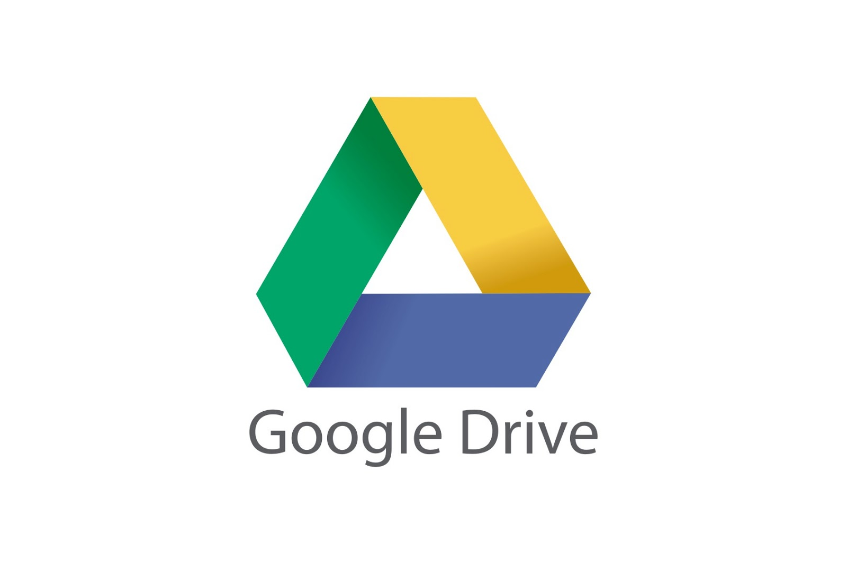
1. Create a gmail account JUST for School
Ex: Lisawilliamsjhs@gmail.com
2. Create a file
3. Share a file ( sharable links to students to use in Edmodo and load up)
Edmodo ( 30 minutes)
https://www.edmodo.com/
https://edmodoteacherhub.wikispaces.com/file/view/Exec-Summary-Edmodo.pdf
http://iteachyoucomputers.wikispaces.com/file/view/edmodo.pdf
https://s3.amazonaws.com/apps.edim.co/edmodo_2015_parents+%281%29.pdf
http://emergingedtech.com/ebook/EmergingEdTech_Free_Education_Technology_Resources_eBook.pdf

Activities for Edmodo
1. Create an account & group codes
2. Create your 6 groups for classroom
3. Create your first test
4. Load up files
5. Connect your Google drive to Edmodo
Weebly ( 30 minutes)
www.weebly.com
http://weeblytricks.weebly.com/
1. Create an Account with weebly (use your gmail.com account)
2. Create a Standard base website setup to load up project samples, projects, classwork, and homework
3. Create the following pages
- Introduction
- Contact Page
- Learn how to load up files on your website

