EverFi Banking Notes

SAVINGS
- Interest- cost of _______________.

- You pay interest on money you _______________and make interest on money you _______________.

- When you are saving money, you are basically giving the bank a loan and they pay you interest. This interest is when the bank pays you a __________________________ on the money you have in your account.

- Simple interest- calculated _______________per year

- Compound interest- pays you interest not only just on the money you deposited, but on your _______________as well. Interest could be paid once a year, twice a year, three times a year, monthly, weekly... even daily!

BANKING
  - Types of Banks:
- _______________- services like savings and checking accounts, mortgages, personal loans, debit cards, and credit cards. For the most part, a retail bank deals directly with individual customers like you, but they may also serve businesses.

- _______________- not-for-profit cooperative banks that are privately owned and controlled by their _______________. Credit unions require membership.

- _______________- allow you to receive a loan in the form of cash before your payday

  - The Federal Reserve
- _______________- put into law so that this, and other financial crises, would never happen again.
- The Federal Reserve (The Fed)- the _______________bank of the US. It oversees the nation's system of money and credit. They print money, control how much is available, adjust long-term interest rates and help steer the economy in the right direction by keeping prices stable and promoting high employment. It is _______________part of the government.
- The Fed is organized into three parts:
  - ______________________________
  - _______________ regional Reserve banks
  - the Federal Open Market Committee (FOMC).
- The _______________ensures that banks behave responsibly. It supervises the 12 Reserve Banks and helps decide monetary policy, like how much money is available to the economy. This is the main governing body of the Federal Reserve.
- The Reserve Banks are the banks out in the field. They collect data and research on the economy and keep an eye on the banks in their regions. They also provide financial services to other banks and to the U.S. government.
- The _______________ is a committee of the Federal Reserve Board that decides the nation's policies about the money supply and interest rates charged to banks.
  - Account Types:
13. _______________: Checking accounts have high liquidity, since they allow you to easily deposit and withdraw money using an ATM, debit card, or personal check. Having a checking account is a smart option if you make frequent transactions. Most of these accounts come with a debit card and checks.

15. _______________: When you deposit money into a savings account, you're able to earn interest on it. Generally, savings accounts are less liquid than a checking account, which means that access to your money is more limited and you may be charged special fees for accessing this account too frequently. But not touching your money is really the whole point of a savings account anyway - you want to put money in this account and keep it there so it can accumulate interest over time.

16. _______________: Certificates of Deposit generally offer a higher interest rate than savings accounts because the bank holds your deposit for a fixed period of time. Access to your money is more limited, and you may be charged a penalty for withdrawing your money before the time period is up, which makes this account type less liquid than a savings account.

14______________________________: HMoney market accounts - also called MMA's - offer a higher interest rate than a typical savings account. You can also write checks from an MMA, but there can be restrictions like a high ongoing minimum balance. You are limited to six (6) withdrawals per year.

  - Explore a Check:
15. The parts of a check (Define and label):

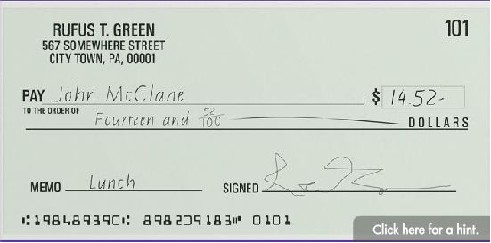

a. Check Number-
b. Numerical Amount-
c. Written Amount-
d. Memo line-
e. Account Number-
f. Signature line-

Payment Types

Payment Types:
- Three major payment types: Paper, Plastic, Electronic
- Paper
  - _______________– most common
  - _______________– must have the money in banking account to cover it or it will bounce which causes a fee
  - _______________– guaranteed by bank that it won’t bounce and cost a fee to purchase
  - _______________- pay up front and can use the money order to pay for goods or services
- Plastic-
  - Debit cards- looks like a credit card, works like a _______________. They are directly linked to checking account and the money comes directly out of your banking account.
  - Credit card- a _______________ that you have to pay back
  - _______________ credit card- store cards which can only be used at that store
  - Prepaid cards- put a specific amount on the card. May have fees.
Credit VS. Debit | Credit | Debit
Repayment | Borrowing money that must be paid back | Paying for items with money from checking account
Interest | Must pay balance to avoid interest fees | No interest since you are not borrowing money
Credit History | Transactions can improve or damage credit history | Transactions do not affect credit history
Fraud | Offers protections | Less protection
Budgeting | You can buy things you don’t have the money for or can’t afford | You can only buy things based on the money in your account
Paying | Sign your name | Enter PIN

Credit Scores
- What is a credit score: _______________rating of your credit that reflects how likely you are to pay back your debts). EX. FICO Score
- Just how important is your credit history and your credit score? It can actually affect a lot more than you might think. In fact, some of the biggest moments in your life may be affected by your credit score:
- A car dealer will run a credit check to see what kind of interest rate you will get to buy a car.
- An employer might check your credit score to see if you're a responsible person.
- A potential landlord will check your score to judge if you'll pay your rent regularly.
- And if you want to get a credit card, the company will run a credit check to see if you're likely to pay your bill each month.
- Your credit score might even affect the type of cell phone you can get.
- Credit Bureaus- companies that collect _______________information about individuals. 3 major bureaus in US: Equifax, Experian, and TransUnion.
- Credit Score Range : _______________
  - Very Poor Credit _______________- need assistance to repair credit history
  - Poor Credit: _______________- High Interest rates and may not qualify for a loan
  - Fair Credit: _______________– possible to secure a loan but terms may not be favorable…High interest rates
  - Okay Credit: _______________– restrict you to higher than average interest rates on loans and lines of credit
  - Good Credit: _______________- you would qualify for most loans
  - Excellent Credit: _______________ - qualify you for most loans and interest rates
- Boost your credit score by:
  - Avoid a low one in the first place
  - Pay all bills on time
  - Manage what you borrow responsibly

- What financial behaviors will typically lead to a low credit score?
  - Maxed out credit cards
  - Fully paid balances
  - On-time payments
  - Long credit history

- Calculating a credit score:
• 35% - _______________- paying bills on time, paying at least min. amount, one late payment has a negative impact.
• 30% - _______________- banks, loans, etc. and how much you owe on your credit. Using high percentage of credit lowers your score.
• 15% - _______________- amount of time you have been using credit.
• 10% - _______________- applying for a lot of new credit. Measured by how often lenders run a credit check
• 10% - _______________ of credit you used. Ex. Credit cards, auto loans and mortgage- having a combination of credit slightly increases your score.
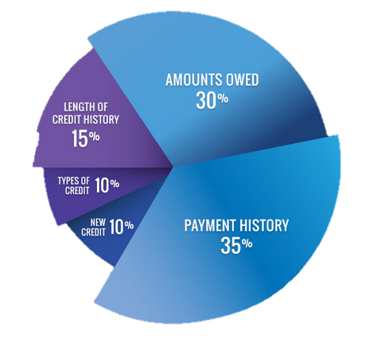
- Actions that will hurt your credit score:
  - Paying bills late
  - Closing old accounts
  - Failing to make payments on a loan
  - Opening multiple cards on the same day
  - Max out credit cards
  - Missing a payment by even 1 day
  - Ignore a doctor’s bill

- Actions to raise your credit score:
  - Using a smaller percentage of credit line
  - Paying off credit card balance
  - Having a mix of credit types
  - Long credit history
  - Paying off loans

- You should check your credit report at least _______________a year.

- You are entitled to one _______________credit report from each of the three credit bureaus for a total of three free reports a year.

