Professional Dress Activity

Directions: Create a PPT for the different types of dress codes. Find images of clothing on the Internet that will create an appropriate outfit for each type of dress code. Include pictures, a description Also, include accessories such as jewelry and shoes.
Save as Professional Dress. Please use people that represent you!

Please proofread for grammar errors and ELA Skills. (punctuation, capitalization and use complete sentences)

Points worth: 100 points

Slides
- Title Slide – be sure to put your name, class period, Professional Dress
- Professional business attire for men
- Professional business attire for women
- Business casual attire for men
- Business casual attire for women
- Casual attire for men
- Casual attire for women

Example:
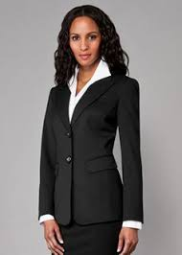

Professional Dress for Women

Macy’s
- Grey Pinstripe jacket with one button closure
- Grey Striped pleated A-line skirt
- Black Peep Toe Pumps
- Pantyhose
- Pearl earrings and necklace.
- White button-down shirt

Do not use my pictures!

Make sure you use transitions between slides and use one theme for the entire slide!

