Name:
Date:
Period:
Standards- IBT-1 Employability Skills

Websites:
https://www.irs.gov/pub/irs-pdf/fw4.pdf
http://media.cygnus.com/files/base/CSN/document/2018/02/fw4[1].pdf

Directions: Identify parts of a W-4 form & students will form out a w-4 form.
Students will fill out an w-4 form and save it as an pdf and submit via Google Classroom

http://media.cygnus.com/files/base/CSN/document/2018/02/fw4[1].pdf

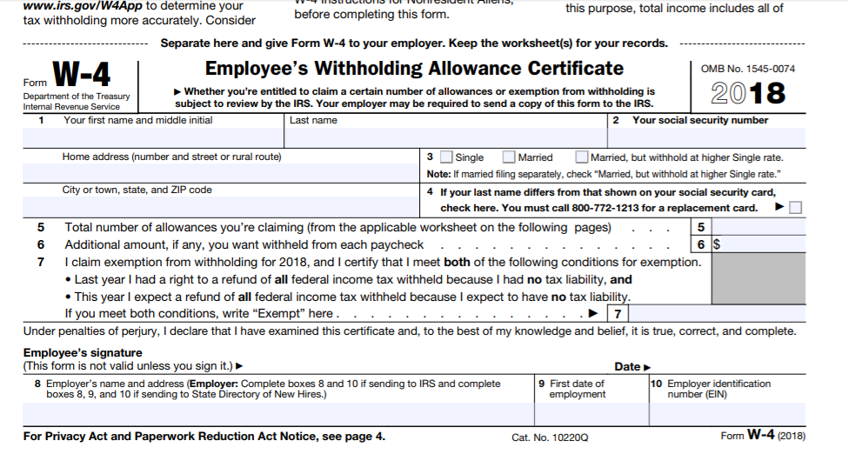

Identify the parts on the W-4 Form

Number on the form  Please insert the proper name for the numbers that are on the form | What does this number mean and represent?  What should you put in that space?
1 Full Name
2
3
4
5
6
7
8
9
10

