Name:
Period:
Standard; IBT-1 Reading a check and a paycheck stub..
Videos
https://www.google.com/search?q=how+to+read+a+paycheck+stub&rlz=1C1GCEA_enUS875US884&oq=How+to+read+a+paycheck+stub+&aqs=chrome.0.0i512l2j0i22i30l8.3962j0j7&sourceid=chrome&ie=UTF-8&safe=active&ssui=on#kpvalbx=_JhUxYdbSEMubwbkPhMiSUA22
https://www.wikihow.com/Read-a-Pay-Check-Stub

https://gusto.com/blog/payroll/how-to-read-your-pay-stub

https://www.opploans.com/oppu/articles/how-to-read-a-pay-stub/

https://www.credit.com/personal-finance/how-to-read-your-paycheck-stub/

https://www.wikihow.com/Read-a-Pay-Check-Stub

Please complete this form: https://forms.gle/in8F7HawAvnUCTqp9

Your paycheck will have two parts. One part is called the check and the second part is the stub. The paycheck tells the bank who the check should be payable to (employee name), how much money to give to the employee (the amount), the name of the company writing the check (employer name and address), and the name and bank account number where the employer keeps their funds (name of bank/account number.) The check portion of your paycheck will be returned to the employer once you have taken it to the bank.
The stub is kept by an employee for their records. The stub tells an employee all of the facts and details about their paycheck such as how many days are covered by the pay period, the amount due to the employees for their salary or hours worked, the amount of deductions taken, and identifying details such as the social security number, employee identification number, as well as the name and address of the employee.
The top part of the check should be taken to a bank where you can either deposit it or cash the bank will exchange the check for cash. At the very least it is important to “pay yourself first” by putting at least ten percent of each check into savings. Sometimes, the funds will be transferred electronically directly to your bank account and a copy of the stub will be sent to you via e-mail. When the funds are sent to you digitally this is called direct deposit.
Below, find a copy of a paycheck as well as a check stub. Please use them to answer the questions below.

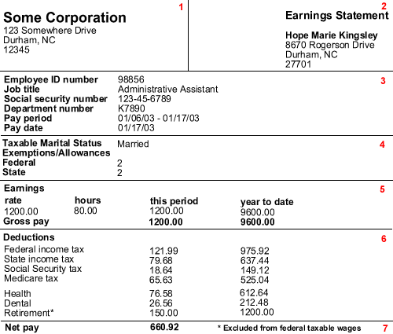

1. How much is the gross pay?
2. How much is the net pay?
3. How much did this employee pay for Federal Income Tax for this check?
4. How much Federal Income Tax has this employee paid to date?
5. What is the name of the employer?
6. Whose check is this?
7. What is the name of the bank?
8. What is the bank account number?
9. What is the pay period for this check?
10. What percentage of the check was lost spent on taxes and benefits?
11. Is this a weekly, biweekly, or monthly paycheck?
12. How much money does this employee make per hour?
13. How much is the retirement deduction for each week?
14. What is the check number?
15. What is the total number of exemptions that this employee is claiming?
16. What is the Social Security number for this employee?
17. How much money has this employee saved for retirement this year?
18. What is it called when funds are sent digitally into you bank account?
19. If you take your check to a bank, what will the bank do with it?
20. Who keeps the paycheck stub?
21. Once an employee takes the check to the bank, who is it delivered to?

Identify the parts of the paycheck | In your own words explain what the numbers are
What is Number 1?

What is Number 2?

What is Number 3?

What is Number 4?

What is Number 5?

What is Number 6?

What is Number 7?

