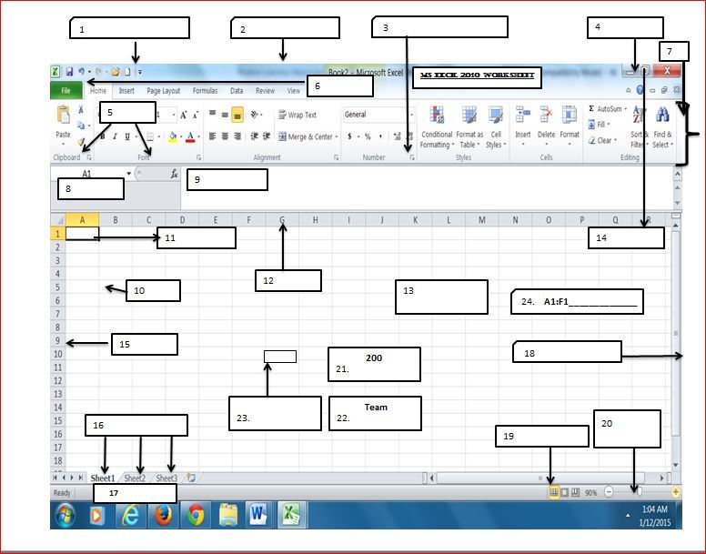

|  |  |
| --- | --- |
| 1 | 13 |
| 2 | 14 |
| 3 | 15 |
| 4 | 16 |
| 5 | 17 |
| 6 | 18 |
| 7 | 19 |
| 8 | 20 |
| 9 | 21 |
| 10 | 22 |
| 11 | 23 |
| 12 | 24 |