Excel Basics Quiz 3 - Identify Areas of an Excel Spreadsheet
Level: Beginner
8 Question Multiple Choice Quiz with Answers
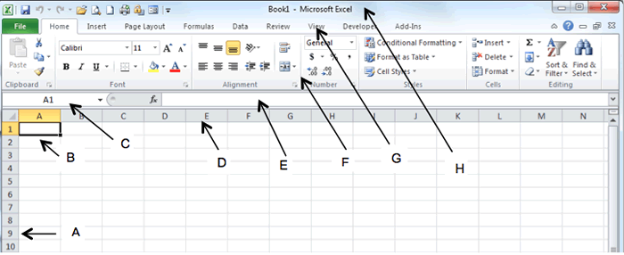
1) What is A in the diagram?
a) Number bar
b) Row numbers
c) Line numbers
d) Numeric labels

2) What is B in the diagram?
a) Cell
b) Box
c) Area
d) Active Cell

3) What is C in the diagram?
a) Name Box
b) Active Cell
c) Status Bar
d) Formula Bar

4) What is D in the diagram?
a) Column letters
b) Letters
c) Column headings
d) Alpha labels

5) What is E in the diagram?
a) Name Box
b) Active Cell
c) Formula Bar
d) Status Bar

6) What is F in the diagram?
a) Menu Bar
b) Commands Bar
c) Buttons Bar
d) Ribbon

7) What is G in the diagram?
a) Ribbon
b) Tabs
c) Menu Bar
d) Commands Bar

8) What is H in the diagram?
a) Status Bar
b) Name Bar
c) Title Bar
d) File Bar

Quiz script provided by
JavaScriptKit.com

