Table of Contents
Module 1 Computers in Your Life
What is a Computer? 2
A Brief History of Computers 3
The Impact of Computers on Society 5
Module 2 Hardware
Input Devices 13
Output Devices 15
Processing Components 16
Module 3 Software
Operating Systems 24
Applications 26
Utility Programs 27
Types of Computers and Computer Systems 7
Ergonomics 9
Key Term Review 11

Storage Devices 18
Networks 20
Key Term Review 22

Upgrades and Installation Problems 30
Malware 32
Key Term Review 34

Module 4A Getting Started with Windows XP
The Graphical User Interface (GUI) 36
Working with Files and Folders 38
Pathnames and File Compression 41
The Control Panel 42

Module 4B Getting Started with Windows 7
The Graphical User Interface (GUI) 50
Working with Files and Folders 53
Pathnames and File Compression 58
The Control Panel 60
Shutting Down 44
Using Help 46
Key Term Review 48

Shutting Down 62
Using Help 64
Key Term Review 66

Module 5 Online Connections and Communications
E-mail, Instant Messaging, Discussion Forums, and Social Networking 68
E-commerce 71

Module 6 Online Ethics, Safety, and Privacy
Ethics and Technology 77
Copyrights and Wrongs 79
Netiquette 81

Module 7 Research on the Internet
Using the Internet 90
Speed on the Internet 91
Techniques for Searching 93
Emerging Technology 73
Key Term Review 75

Staying Safe Online 84
Key Term Review 87

Evaluating Web Sites 96
Useful Online Resources 98
Key Term Review 100

What Is a Computer?

A computer is an electronic device that processes data and converts it into information that people can use. Whether they know it or not, people use computers every day. Chances are you cannot imagine a world without computers!

computer technology
Computers are everywhere-in ATMs, drive-up windows, and cars. Computers are more common than ever before-almost every office desk in the country has a computer on it, and most schools have them in classrooms. The majority of Americans have PCs and web access at home, according to the U.S. Census Bureau.
Learning about how computers work can make your life a little easier. That is because computers have completely transformed the way we work, play, and live.
Some computer games are so realistic that you can see, hear, and sometimes even feel the action around you! Games, of course, provide hours of entertainment to people of all ages. Pilots even use computer simulations to learn how to fly.
Common conveniences such as fast food restaurants and ATMs use computers to provide quick, easy service to customers.
Heart monitors, full-body scanners, and other medical devices are run by computers. Doctors use computers to identify problems before them become untreatable.
E-mail and cell phones make it easy to contact friends and family-even if they live on the other side of the world! Video conferencing through computers or mobile phones allows us to see people thousands of miles away and even feel like we are in the same room them.
The term technology refers to the practical application of an art or skill. Computers are the product of many different advancements in technology. Nearly every corner of the globe has been touched by technology.

Answer the questions on a separate sheet of paper.
Identify What aspects of your life do not involve computers?

Make Predictions What would life be like without computers? How would your life change if computers suddenly disappeared from the world?
Interview Talk to someone who is older than you, such as a parent or a grandparent. Did they use computers when they were young? How was their life different from the way you live now?

A Brief History of Computers

Some of the first computers were built during World War II (WWII). They were built to perform the many calculations necessary to break codes transmitted by the enemy.

Moore’s Law
The first American computer built during WWII was called the ENIAC (Electronic Numerical Integrator And Computer). The ENIAC filled a 30-by-50-foot room and had 18,000 vacuum tubes and 6,000 switches. At 5,000 calculations per second, the ENIAC was much faster than any computer before it. However, it had to be rewired for each new calculation. In 1944, Howard Aiken introduced the first fully functional computer: the Harvard Mark I.
The Harvard Mark I was 55 feet long and 8 feet high. It was slower than the ENIAC, but it did not have to be rewired for new calculations.
Computers were mostly used by large businesses and by the government until the mid-1970s, when personal computers were first built. However, in 1965, Gordon Moore made a prediction that became known as Moore’s Law. Moore predicted that the number of transistors on an integrated circuit, or microchip, would double every couple of years. As it turns out, his prediction has been fairly accurate.
The increase in the number of transistors made it possible for computers to become much smaller than the ENIAC and the Harvard Mark I. Compared to the room-filling ENIAC, today’s laptops are about the size of a coffee table book. And they are far more powerful. An average laptop today is about 300,000 times faster than the ENIAC.
The first “personal computer” was the Altair 880. It became available for commercial purchase in 1975 and cost about $400. The Altair 880 came in a kit that the user had to assemble.
The Apple II came out in 1977. It came fully assembled with a built-in keyboard. However, users had to plug the computer into a television set to use the monitor. In 1981, IBM introduced the personal computer. It became enormously popular for business and personal computing.
The model for the Internet was developed in 1973 by American computer scientist Vinton Cerf. It was originally intended for use by scientific researchers. The World Wide Web was created in 1989 by Sir Tim Berners-Lee at a physics lab in Geneva, Switzerland. Communicating via e-mail became commonplace in the early 1990s. The advent of the Internet also led to the growth of virtual learning environments during the 1990s.
A personal digital assistant called the Pilot, manufactured by Palm Computing, was released in 1996. It was extremely popular because of its capabilities and ease of use.

The first decade of the 21st century marked the rise of mobile computing (facilitated by advances in wireless technology), communicating and sharing over networks, social networking, and netbooks.

The information in this Technology Handbook will help you better understand how computers work and how to make them work for you.
In 2001, Apple introduced the iPod, a portable media player that became very popular. Skype, an application enabling voice calls over the Internet, was introduced in 2003. Also in 2003, the professional networking site LinkedIn appeared online. In 2004, the social networking sites MySpace and Facebook were launched, followed by Twitter in 2006. The photo-sharing site Flickr appeared online in 2004. The video-sharing site YouTube followed in 2005.
In 2006, Nintendo released the Wii, a home video game console with a wireless controller. In 2007, Apple released the iPhone, a smartphone enabled for the Internet and multimedia. Text messaging (exchanging brief messages between devices over a network) exploded in the United States by 2008. The social networking site Foursquare, a location-based service (LBS) allowing users to “check in” at venues using their mobile devices, was launched in 2009. Netbooks, smaller and more portable than traditional laptops, became popular at the end of the decade.
The first decade of the 21st century marked the rise of mobile computing (facilitated by advances in wireless technology), communicating and sharing over networks, social networking, and netbooks.

Answer the questions on a separate sheet of paper.
Reproduce What is Moore’s Law?

Summarize Write a paragraph that summarizes the invention and development of computers.

Analyze Why do you think it might be difficult for computer buyers to keep up with emerging technology?

The Impact of Computers on Society

Computers have transformed the world. They have changed everything from shopping to movies to the kinds of jobs that are available. Technologists believe that we have only begun to imagine the impact of computers on our society.

e-commerce surveillance
Overall, computers have made it easier for businesses to exchange information. E-mail and access to information, such as stock market information, have increased the speed of business. People who work together do not have to do so at the same time or in the same place. Many services and information are available 24 hours per day.
- commerce, or electronic commerce, is the buying and selling of products and services over the Internet. E-commerce enables businesses to make shopping easier for their customers.
Computers can help people become more organized and can perform technical or tedious tasks such as drafting plans for a new car or dispensing money to bank customers.

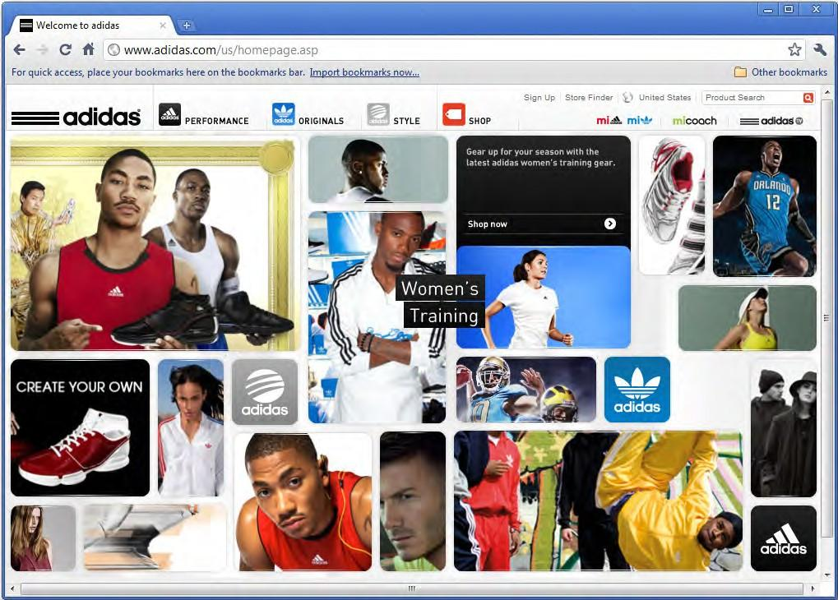

The need to build new computers and maintain existing computers has introduced dozens of new types of jobs. Building computers is a complex process, and many people are needed to build one computer. Once a computer has been built, it must be maintained. There are numerous jobs that help people keep computers running smoothly. People are also needed to create software for computers.

For more information about e-commerce, see Module 5 in this handbook.
In addition to creating new jobs, computers have decreased the demand for other jobs. Computers have reduced the number of bank tellers, telephone operators, mail sorters, loan interviewers, to name a few.
Computers have made surveillance, monitoring and watching people, easier than ever. Privacy and security issues are being debated in courtrooms every day. Data is being collected on millions of people and sold to virtually all types of businesses.

These are just a few of the ways that computers have changed the world. What other ways can you think of?

Answer the questions on a separate sheet of paper.
Define What is e-commerce?

Explain What are possible negative outcomes of surveillance technology?

Discuss Write a paragraph that discusses the positive and negative impacts that computers have had on society.

Types of Computers and Computer Systems
In today’s world, computers are everywhere. They come in different shapes and sizes and they serve different purposes. Computers can be grouped in several different ways: by size, by purpose, and by how many people use them.

personal computer (PC) desktop
laptop netbook smartphone Macintosh minicomputer mainframe

  - A personal computer (PC) is used by one person at a time. Desktop and laptop computers, tablet PCs (such as iPads), and smartphones are all examples of PCs, which are also called microcomputers. Personal computers come in all shapes and sizes to meet various technology needs. A desktop computer is designed to remain in one location. A laptop computer is designed to be carried from place to place. A netbook is even smaller and lighter than a conventional laptop, with many of the same capabilities. A smartphone, sometimes called a personal digital assistant (PDA), is a
handheld computer with cell phone capabilities. Sometimes, the term PC is used to identify a personal computer that uses the Windows operating system (OS), as opposed to a Macintosh computer, which uses the Macintosh OS. The PC and the Macintosh are very much alike. A company called Apple makes Macintosh computers. Several different companies make PCs.
- A minicomputer can be used by several people, even up to hundreds of people, at once. These computers are used in small- to medium-sized organizations, such as schools, hospitals, hotel chains, banks, and churches.
- A mainframe, or supercomputer, is large enough to fill several rooms. These computers are used by thousands of people at the same time in organizations such as government agencies.

Computer companies are no longer racing just to make the most powerful computers; they are also seeking to make them as small as possible.

Just like a desktop or laptop computer, a smartphone has an operating system that can run applications, commonly called apps.
Desktop computers and their screens fill up less workspace than in years past. Laptops are smaller and lighter than before.
Today’s smartphones are more powerful than many of the desktop computers were 10 or 15 years ago.

Answer the questions on a separate sheet of paper.
Describe What is the difference between a laptop computer and a desktop computer?

Predict Which type of computer would be most useful for someone who travels a lot??

Explain How are PCs and a mainframe different? Which type of computer might be used by a large company? Why?

Ergonomics

Ergonomics is the study of the relationship between humans and the objects that we use. The term is derived from two Greek words: ergon, meaning “work,” and nomoi, meaning “natural laws.” Ergonomists are people who study human anatomy in order to determine how the objects that we use can be made safer, more comfortable, and more efficient.

ergonomics ergonomists
For example, if you are going to be spending time in front of a computer, it is important that you minimize stress to your body. Here are some important things to keep in mind:

- Make sure you use a chair that provides strong back support. Be sure to keep your back straight while working, and keep your feet flat on the floor.
- Keep your wrists straight while you are typing. If your keyboard includes a “wrist rest,” be sure not to use it while typing. Resting your hands while keying causes the wrists to bend, which causes muscle fatigue and can put you at risk for injuries.
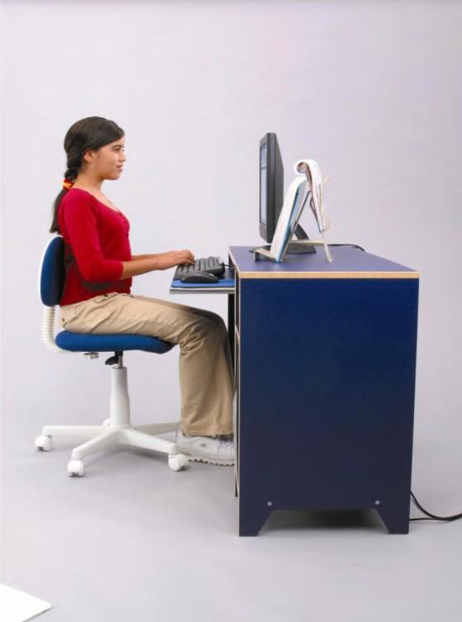
- Position the monitor so that it is just a little below eye level and about two feet away. This will prevent strain on your neck muscles.

MODULE 1
9
- Make sure there is enough light in the room so that you can easily see the monitor without straining your eyes.
- Keep your monitor’s resolution set to a comfortable level. The highest possible resolution setting is not necessarily the best. Choose a resolution that displays images and text at a size that is comfortable to view.
Ergonomists do more than recommend how to sit at a computer. They are becoming increasingly involved in product design. Some ergonomists believe that product manufacturers are too far removed from the users of their products. In other words, these ergonomists believe that when manufacturers plan the design of their products, they often do not take into account the users’ physical limitations or comfort.
The body parts that are most vulnerable to cumulative- trauma are the back, hand, wrist, forearm, and neck.

Technology Handbook

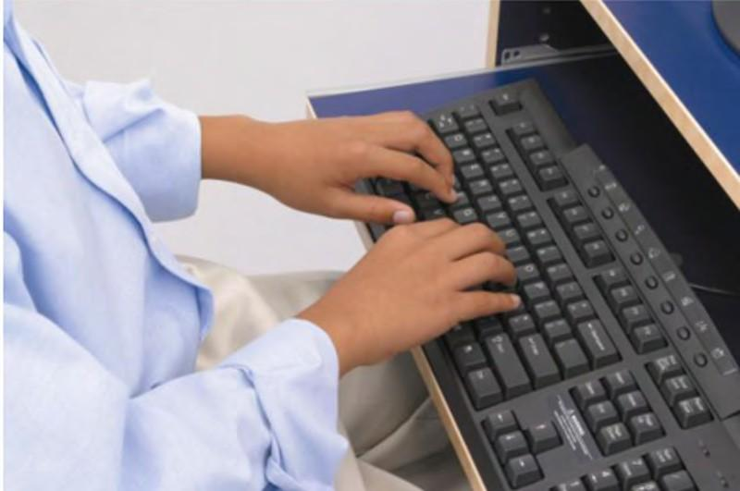
Ergonomists want to help manufacturers use product design that prevents discomfort and injury. Manufacturers of computer- related products have begun to offer a wide array of ergonomically designed accessories, including ergonomic computer chairs, mice, mouse pads, arm rests, foot rests, keyboards, and writing instruments. The design of all of these ergonomic products attempts to reduce the forces that act upon the body.

Why use ergonomics? Injuries that are related to poorly designed tools
or work environments are not only painful, they are costly. According to the Bureau of Labor Statistics, nearly half of all worker-compensation costs each year are due to ergonomic-related injuries. Such injuries can lead to cumulative-trauma disorders, which occur because muscles are repeatedly stressed, nerves are pinched, or blood flow is restricted. Protecting the body against these injuries will not only help you avoid pain, but it might also help both you and your company avoid costly medical expenses.

Answer the questions on a separate sheet of paper.
Define What is ergonomics?

Give Examples What are some computer-related products that have been ergonomically designed?
Explain How might an employer suffer by providing ergonomically unsound workstations?

- A(n) is an electronic device that processes data and converts it into information that people can use.
- refers to the practical application of an art or skill.

- predicted that the number of transistors in computer circuits would double every couple of years.
- Buying and selling products and services over the Internet is called , or electronic commerce.
- Computers have made , monitoring and watching people, easier than ever.
- A(n) is a computer that is used by one person at a time.

- A(n) computer is designed to remain in one location.

- A(n) computer is designed to be carried from place to place.

- A(n) is a computer that is small enough to hold in one’s hand.

- A company called Apple makes computers.

- A(n) can be used by up to hundreds of people at once.

- A(n) , or supercomputer, is large enough to fill several rooms.

- is the study of the relationship between humans and the objects that we use.
- A(n) studies human anatomy in order to determine how the objects that we use can be made safer, more comfortable, and more efficient.

Concept Review

- The first fully functional computer was called the .

- The increase in the number of made it possible for computers to become much smaller.
- A mainframe is the best type of computer when there are of users.

- Surveillance technology has raised important issues concerning and
.

- Ergonomics are incorporated into product design to help prevent discomfort and
when using a product.

Critical Thinking

- Defend Is the computer a positive or negative influence on society? Write a short, three-paragraph essay in which you argue that the computer is either a positive or negative influence on society.
- Develop Create a diagram similar to the one below. Fill in the diagram with five events in the history of computers.

Input Devices

Anything connected to your computer is considered a peripheral. In order for a computer to work, it must first have data. You can use peripherals called input devices to put information into a computer.

peripheral input devices keyboard mouse scanner joystick microphone digital camera port
A keyboard is one of the most common input devices. You can use a keyboard to enter information in the form of letters, numbers, and punctuation. By pressing combinations of keys, you can also give commands to some programs.
You use a mouse to control objects you see on a computer screen. Using a mouse, you can point to
objects, select objects, and move objects. You can open programs, delete

files, and create new folders. A mouse allows you to give information to a computer in a variety of ways.
A scanner converts printed documents or images, such as drawings and photographs, into digital files. Once the printed document or image has been scanned, the scanner sends the information to the computer.
A joystick is an input device that usually has buttons that can be pressed to send instructions to the computer.
Joysticks, game pads, and simulated race car steering wheels are just some of game controllers that you can use to input commands when playing computer games.

A microphone can be used to input audio such as music into a computer. Voice recognition programs allow individuals to enter text into a computer by speaking into a microphone.
A digital camera captures photographs as digital files that can be uploaded directly to a computer. A digital camcorder is used to create original video files.
Other computer input devices include touchpads (trackpads), touchscreens, graphic tablets, interactive whiteboards, webcams, and synthesizers.

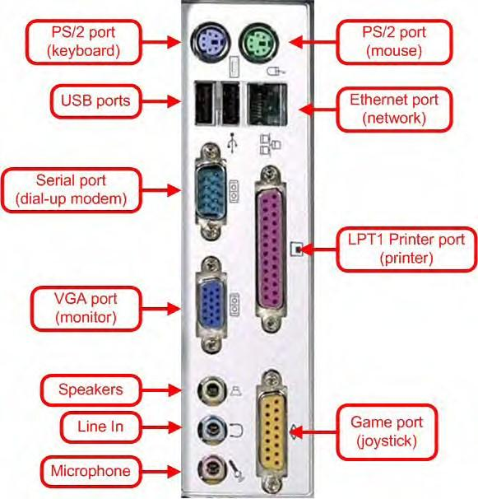
Many input devices must be plugged into the computer before they can be used. A port allows users to connect external input devices to the computer system. Ports are usually located at the back of the computer.

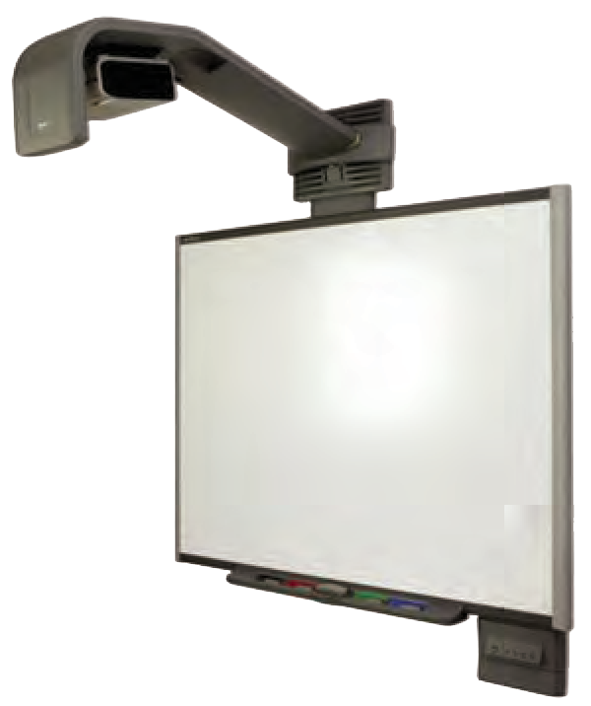

Answer the questions on a separate sheet of paper.
Differentiate What type of information would you enter into a computer using a keyboard?
Relate In this topic, you learned about keyboards, mice, and scanners. Think of three other devices that can be used as input devices.

Output Devices

You have learned that input devices put information into a computer. An output device carries information out of a computer. First, the computer changes the information into something usable. Then, the output devices present the information to the computer user.

output device monitor printer speaker
A monitor, which is also called a computer screen, displays information visually, just like a television set. An LCD (liquid crystal display) monitor is much thinner than a CRT (cathode ray tube) monitor.
You use a printer to transfer images from a monitor to paper. For instance, when you type an essay on a computer, you can then print it out to turn in for class.
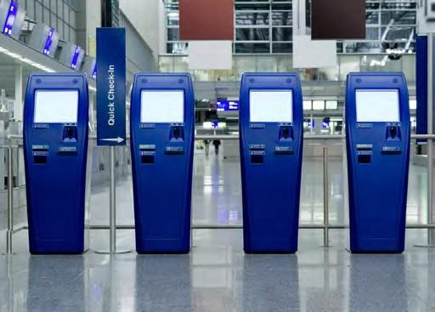
A speaker carries information in the form of sound. Speakers can output music, speech, and noises.

Other output devices include touchscreens, interactive whiteboards, and headphones.

You can use a printer to print pictures, as well as documents

Answer the questions on a separate sheet of paper.
Activity Information flows out of a computer through output devices. Create a diagram that shows
information flowing from a computer to three different output devices. Write a brief explanation next to each output device that explains what sort of information the device outputs.

Processing Components

A computer uses hardware to process data into useful information. The part of the computer that processes information has many parts that work together.

process microprocessor motherboard clock speed CPU
memory RAM ROM
storage device
The microprocessor is the brain of a computer. The microprocessor is located on the motherboard, which is the computer’s main circuit board. A computer makes almost all of its calculations in the microprocessor. Not all microprocessors are the same. Some can perform more calculations per second than others. A processor’s clock speed is the number of calculations the processor can perform each second.
The CPU, or central processing unit, is made of one microprocessor in small computers. In larger machines, the CPU can be made of several microprocessors.
Memory, where computers keep their information, comes in the form of computer chips.

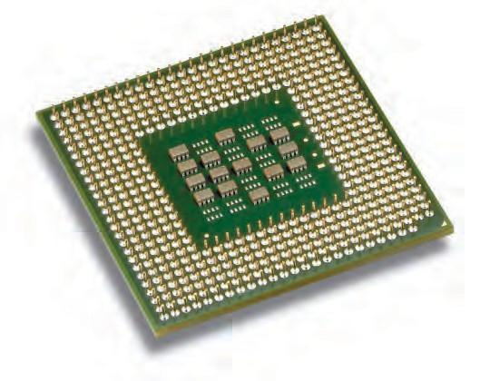

Memory chip
Motherboard

RAM, or random access memory, holds information temporarily. ROM, or read-only memory, is the permanent information on a computer.

Today’s smartphones process data many times faster than the early mainframe computers.
A storage device, also called a secondary storage device, is another place where information is kept in a computer system. Unlike memory, however, storage devices hold information permanently. Storage comes in the form of hard disks, zip disks, optical disks, and flash memory.

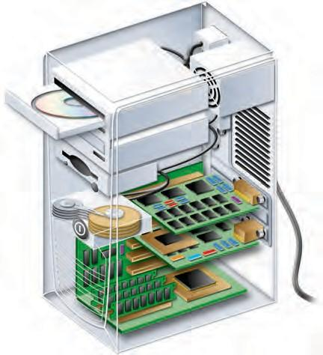

CPU
Storage device
Storage device
Storage device
RAM

Answer the questions on a separate sheet of paper.
Describe List three pieces of hardware in a computer and explain what each does.
Compare How are memory and storage alike? How are they different?
Classify What makes some microprocessors different from others?

Storage Devices

As you have already learned, computers change data into useful information. Computers are also useful for storing information. In this section, you will learn about some of the devices that are used to store information.

hard drive zip disk
flash memory optical disk CD-ROM DVD-ROM CD-R
CD-RW BD
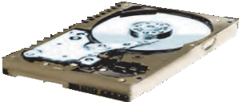
A hard drive, also called a hard disk, is the most widely used secondary storage device. Hard drives can be internal or external. Hard drives today can usually hold 120 to 500 gigabytes of data. One gigabyte is equal to 1000 megabytes. A hard drive with 120 gigabytes could hold more than an entire library floor of journals and magazines!
A zip disk, like a floppy disk, has a portable disk inside a plastic case. A zip disk can hold 100 to 750 megabytes. Seven hundred fifty megabytes is
roughly equal to 15 volumes of an encyclopedia!

Flash memory uses chips to hold information. You can add information to flash memory in large chunks rather than piece by piece, making storage faster and easier than with other types of memory.
All of the storage devices you have read about so far use electric charges to store information. Optical disks, another type of storage device, use lasers to read and write information. Five types of optical disks are explained in this article.
A CD-ROM is an optical disk that can hold up to 1 gigabyte of information. One gigabyte of information is equal to 700 floppy disks or 300,000 pages of text.
Like the CD-ROM, a DVD-ROM is an optical disk. However, the DVD- ROM can hold up to 17 gigabytes of information. It would take 17 CD-ROMs to hold the information in one DVD-ROM. DVD-ROMs are commonly used to store movies.
A CD-R, which stands for Compact Disk-Recordable, is a CD-ROM that does not yet contain any information. A CD-R drive writes information onto the CD-R. A CD-R can hold about the same amount of information that the CD-ROM can hold.
Information can only be put on CD-ROM and CD-R once. A CD-RW, short for CD-Rewritable, is an optical disk that can record information many times. CD-RWs are useful for making copies of important information for backup.

A BD, or Blu-Ray Disc, is an optical storage disk designed to compete with the DVD format. Its high capacity allows it to store high-definition (HD) movies.

Combination DVD/CD drives are common in PCs. DVD drives can read CDs.
If you have problems using a storage device, try the basic troubleshooting procedures below.

For Optical Disks:

  - Make sure the CD, DVD, or BD is seated right side up in the disk tray. The shiny side should be on the bottom. Make sure there is not more than one disk in the tray.
  - If a disk will not work, as a last resort, wipe it with a very soft cloth. Wipe the shiny side gently from the center of the disk outward. Ask your teacher or a parent before attempting this.

Answer the questions on a separate sheet of paper.
Distinguish Describe two ways that flash memory is different from other storage devices that were
discussed in this section.

Identify What are the storage capacities of zip disks and hard drives?
Describe Describe two things you can do if your CD-ROM is not working.

Networks

When computers are properly connected, they can share information. By sharing information, a group of computers becomes a more useful resource than one computer by itself. A network is a group of computers that are connected to each other. There are two basic types of networks.

network LAN WAN
network hardware network operating system (NOS)
network interface card (NIC)
ethernet cable router
server
network topology
A LAN, or local area network, is a connected group of computers that are close to one another. For example, a connected group of computers in a home or in an office is a LAN. LANs are often used to allow several computers access to one printer.
WAN, or wide area network, is a connected group of computers that are not close to each other. For example, the Internet is a WAN. A WAN provides users with access to large amounts of information.

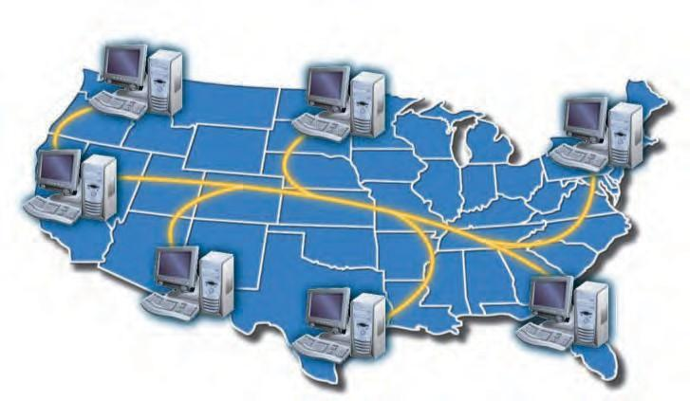

Connecting computers properly so that they can communicate is challenging. Devices called network hardware and software called network operating systems (NOS) help computers share information. All computers on a network need a network interface card (NIC) so that the computers can communicate over the network.
One way to connect computers is by Ethernet cable. Information travels through the ethernet cable from one computer to another.
A router connects multiple computers to each other as well as to a WAN like the Internet. Thus, the computers connected to the router can communicate with one another. They can also obtain information from the Internet.

A server manages the flow of information on a network. This allows network resources, such as files and printers.
A network topology is the actual arrangement of computers in a network. Three network topologies are shown below.

Network Star

Network Bus

Network Ring

Answer the questions on a separate sheet of paper.
Differentiate What is the difference between a LAN and a WAN? Describe one use for a LAN and
one for a WAN.

Predict Based on what you have learned about star networks and ring networks, what do you think a star-ring network would look like?

- Anything connected to your computer is considered a(n) .
- You use a(n) to control objects you see on a computer screen.
- A(n) can be used to input audio such as music into a computer.
- A(n) allows users to connect external input devices to the computer system.
- A(n) , which is also called a computer screen, displays information visually.
- You use a(n) to transfer images from a monitor to paper.
- The is the brain of a computer.
- is the number of calculations the processor can do each second.
- , or random access memory, holds information temporarily.
- The is the main circuit board in a computer.
- is a type of storage that uses chips to hold information.
- are storage devices that use lasers to read and write information.
- A(n) is a group of computers that are connected to each other.
- A(n) is a connected group of computers that are close to one another.
- A(n) is the actual arrangement of computers in a network.
Concept Review

- Information goes into a computer through and comes out through
.

- Most of the calculations done in a computer take place in the .
- Disks that are used to store information for a long time are called .
- A group of connected computers that are far apart is called a(n) .
- A(n) manages the flow of information on a network.

Critical Thinking

- Organize Computers are very useful for dealing with all kinds of information. Create a chart that shows how a basic microcomputer system handles information. The chart should show the flow of information, where information is stored, and where it is processed. The chart should contain the following items:

  - at least three input devices

  - at least three output devices

  - memory

  - storage

  - processing

- Compile Create a table that you can use to evaluate or compare microcomputer systems. On the left side of your paper, create a column that contains at least seven categories (such as “Amount of Memory”) that you can use to evaluate a computer system. Find an online computer store or look at an advertising flyer. Look up two different computer systems and fill in the categories you have created.

Operating Systems

A computer’s operating system is a program that runs the computer. It recognizes input from input devices, sends output to output devices, and saves data and information on the hard disk. A computer user controls the operating system with a command. A command tells the computer to perform a particular task.

operating system command
graphical user interface (GUI)
Users of Linux-based operating systems may need to type in commands to tell the computer what to do. More popular operating systems such as Windows
and Macintosh use a graphical user interface (GUI). A GUI uses images on a monitor to make an operating
system easier to use. Instead of learning command words, a GUI user can choose from a list of options.

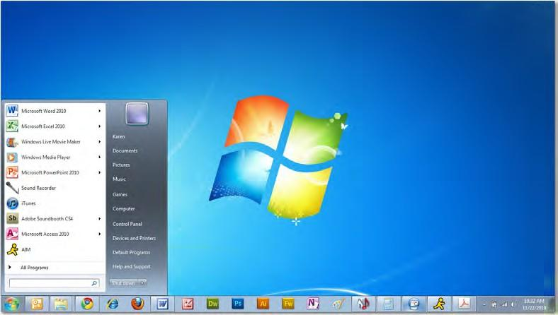

There are three main types of operating systems.

  - Personal operating systems (personal OS), which are designed for a single user. Personal OSs are used to operate technology such as personal computers, laptops, and PDAs.
  - Multi-user operating systems (multi-user OS), which allow many people to use a central computer, such as a minicomputer or a mainframe computer. This operating system is often used by small- to medium-sized organizations.
  - Network operating systems (network OS or NOS), which allow hundreds or even thousands of users to share information across a network. NOSs are used by large companies and government organizations.

The most common models of personal operating systems are discussed below:

The Linux operating system can be used to run devices ranging from mobile phones to supercomputers.
The Microsoft Windows operating systems are the most popular operating systems for home computers. Most PCs and laptops come equipped with a version of Microsoft Windows, such as Windows 7.
Mac OS is the operating system installed on Apple computers. Although Mac OS includes a graphical user interface that is similar to that of the
Windows operating systems, Mac OS definitely looks and feels different than the Windows family of operating systems.
Linux is an open-source operating system, which means that it is free for anyone to use. Linux is said to run the 10 fastest supercomputers in the world.
Ubuntu is a free and open-source operating system designed primarily for desktop computers. Originally based on the Linux operating system, Ubuntu has a GUI.
Chrome is a Linux-based operating system developed by Google. It is essentially a web browser that accomplishes tasks by utilizing Web applications.
Smartphones have their own operating systems. Operating systems for smartphones include Symbian, Android, iOS (iPhone), RIM (BlackBerry), Windows Mobile, Palm, and Linux. All of these offer many of the same features, such as a datebook, an address book, e-mail, and Internet.

Answer the questions on a separate sheet of paper.
Explain Why are commands important?
Predict Why do you think operating systems with GUIs are more popular than those that use word commands?
Describe What is the difference between Windows OS and Mac OS?

Applications

Today, people use computers for everything from writing a letter to calculating a budget, but it is not a computer’s operating system that does these things.

application
word processing application
spreadsheet presentation database
The operating system only runs the computer. An application is the program
that is designed for a particular type of task, like writing a letter or calculating a budget. Applications, however, will not work without an operating system.
Many types of applications serve different purposes. Four of the most common application types are word processing, spreadsheet, presentation, and database.
The table below explains each of these types.

Application Type | What does it do? | Examples
Word Processing | A word processing application produces text documents. You key words into the computer on a keyboard. | Microsoft Word AppleWorks Word Processing Adobe Buzzword
Spreadsheet | A spreadsheet is a table organized into rows and columns. You enter numbers in the table. The spreadsheet can do calculations with the numbers in the table. | Microsoft Excel AppleWorks Spreadsheet
Presentation | A presentation is composed of slides that contain information and graphics. A presentation program helps you make a presentation look organized and eye-catching. | Microsoft PowerPoint Apple Keynote Adobe Captivate  AppleWorks Presentation
Database | A database is an organized way to store information so that it is easy for the computer to search the information. For instance, you might use a database to store your friends’ names, phone numbers, and addresses so that you can easily look up a number or address using a friend’s name. | Microsoft Access FileMaker Pro Oracle Database  AppleWorks Database

Answer the questions on a separate sheet of paper.
Distinguish How are operating systems and applications different?
Discuss List three things you could use a word processor for.

Utility Programs

A utility program is a program that performs a specific task within an operating system. Utility programs perform a variety of tasks, including security. Computer security is very important because there are more threats to computers than ever.

utility program firewall encryption
file management
One of the most common threats is called a virus. A virus is an unwanted program running on a computer. A virus makes copies of itself and, in some cases, sends copies to other computers. Viruses can use up a computer’s
memory or harm the data stored on the computer.

An antivirus program detects and eliminates viruses before they can harm a computer. Good antivirus programs obtain new information about viruses from the Internet.

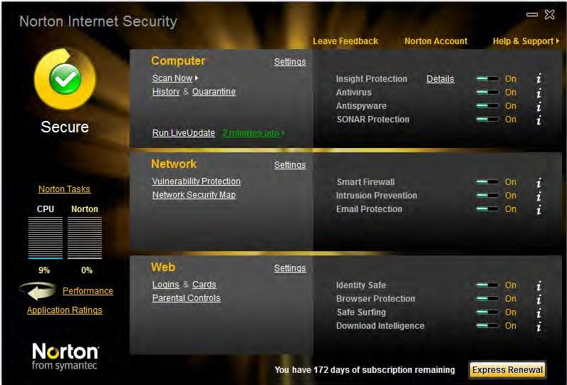

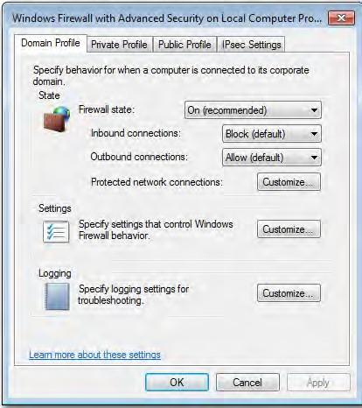

The function of a firewall within a network is similar to the firewalls that are used in building construction. Those are intended to contain and delay structural fire from spreading to adjacent structures.

Another threat is unwanted connections to or from the Internet. These connections can be from viruses or from other users who are attempting to gain control of another computer illegally. A firewall is a utility that protects computers against unwanted connections.
A firewall examines each piece of data that comes into a computer or leaves a computer. If the firewall detects a threat, it will block the data.
Some people have information stored on their computer that they do not want everyone to see. For instance, a company that has created a new invention might want to keep the plans secret until they can patent the invention. People can protect their information by using encryption, or putting data into a code.

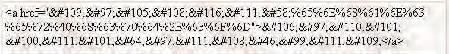

In order to view an encryption, a user must know the key. The key is a string of numbers without which the information will not make sense.

Utility programs accomplish a number of tasks aside from maintaining the security of a computer.

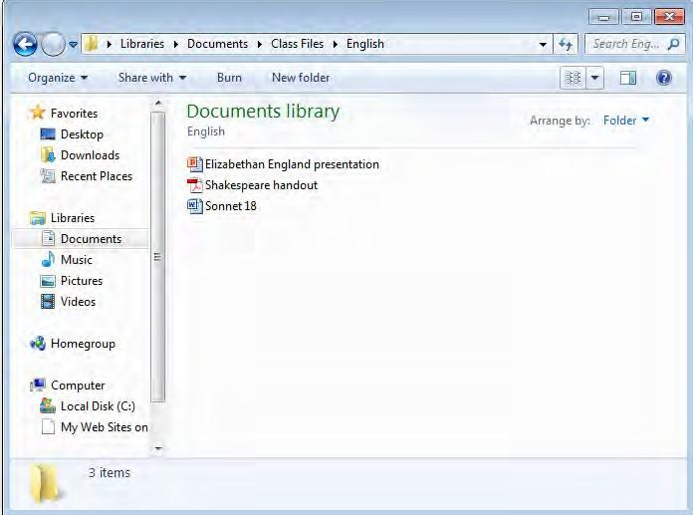
A file management utility organizes files and information so that they are easy to locate.

The most common file system is called a hierarchical file system. Microsoft Windows 7 operating system hierarchical file system is shown here.
Windows has a group of utilities that make computers easier for people with visual or mobility impairments to use. For instance, a person who cannot type can use the virtual keyboard to click the letters.

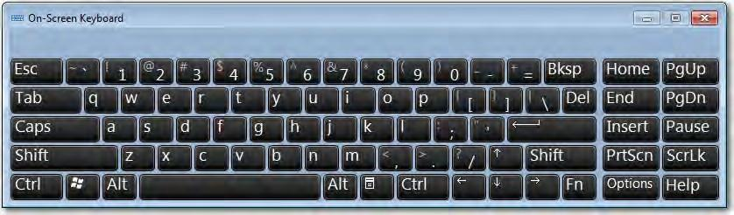

On-Screen Keyboard

Answer the questions on a separate sheet of paper.
Discuss What are the benefits of antivirus programs?
Construct To create a hierarchical file system, think of your favorite pastime. It might be playing baseball or reading books. Make a list that describes your pastime. The first item on the list should be the broadest category to which your pastime belongs. Each new item should be more specific than the previous item and the final item should be your pastime.

Upgrades and Installation Problems

Since software companies produce new versions of their applications every few years, many users choose to upgrade their application software.

upgrading troubleshooting
Upgrading is a process that updates software in order to add new features and
fix problems such as bugs and compatibility with new hardware, operating systems, or other types of software.
Benefits of upgrading include access to better functionality and the ability to use new hardware and software. Drawbacks could include incompatibility with older hardware and software, conflicts with existing programs, or getting used to new technology that ends up not being popular. You can install upgrade software from a CD-ROM, Internet download, or automatic online updates.

Stay informed to find out about the advantages or disadvantages of available upgrades by reading industry news or frequently visiting a manufacturer’s web site.
It is important to identify and understand common problems associated with installing and running applications. A few examples are defective or lost installation media, an installation program that will not start, an installation that stops before completion, an installed program that does not appear on the computer, an installed program that fails to work, an installed program that causes other programs to fail, files that cannot be read by the new application, or not being able to install or uninstall applications, sometimes prevented by an office or school system administrator.

Once you encounter a problem, there are several help options available. The first line of defense is the instruction manual that came with the software. It is important that you are familiar with the material in the application manuals. You will save a lot of time by knowing where to find help in the application manuals. Often there is a “troubleshooting” section that can help you. Troubleshooting is the process of identifying and correcting problems.

If you are unable to solve a software problem using the instruction manual, visit the manufacturer’s website for any updates.
Next, consider those around you who might be able to help. A school administrator or corporate IT professional, a friend, or a family member
with experience using the software can try to help you solve the problem.

Answer the questions on a separate sheet of paper.
Explain What does “upgrading” mean?
Discuss Name one drawback to upgrading software.
Summarize What should you do if you encounter a problem installing software?

Malware

There are thousands, if not millions, of harmful programs roaming the Internet. This malware (short for malicious software) is designed to attack or destroy computer systems, or at least irritate the user. Malware includes viruses, worms, Trojan horses, spyware, adware, and other injurious programs.

malware virus worm
Trojan horse spyware adware
antivirus software
A virus is a computer program that copies itself into other programs stored in a computer. It may only be annoying, causing your computer to slow down, or it may be very destructive, erasing important files or corrupting computer memory. Worms are a type of virus that copy themselves over and over again until they fill all of the storage space on a drive or network.
Trojan horses are programs that appear to be desirable but gain unauthorized access to a computer system. Spyware and adware are two
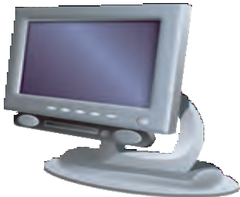
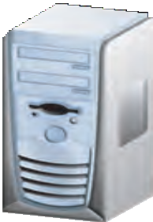
other examples of “sneaky viruses.” Spyware spies on what types of web sites you visit and what software you use.
Adware forces unwanted advertising onto your computer
screen. Spyware and adware are not specifically designed to harm your computer, but they usually end up causing systems to slow down or even shut down.
Dangerous programs can enter a computer in many different ways. They can be hidden in infected files passed from computer to computer on disks, in e-mail attachments, or in Internet downloads. It is important to understand that a text file alone (.txt) cannot be infected.
This is because text itself contains no programming. Other text-based files (e.g., .HTML or ASCII) can contain viruses, but it is the programming that becomes infected.
Fortunately, there are many ways to protect your computer from viruses and worms. Protecting your computer is as important as knowing how to use software applications.

Symantec’s Norton, McAfee, Webroot, and Panda are just a few of the popular brands of antivirus software.
Antivirus software is software that combats viruses. Especially with an Internet connection, antivirus software can BE updated on a daily basis to prevent viruses from entering your computer.

Be very careful about what types of files are downloaded. Make sure you know what the file is and the source of the download. Always perform an antivirus scan.
Never open e-mail attachments from somebody you do not know. Always scan incoming e-mail and attachments before they are opened.
Remember that staying informed of the latest virus threats and keeping anti-virus software up-to-date will help identify, isolate, and clean infected files.

Answer the questions on a separate sheet of paper.
Recall What is a type of virus that copies itself until it completely fills up a computer’s storage
space?
Reproduce What are two types of harmful programs that are not designed to harm your computer but can still cause serious problems?
Explain What are two ways a virus can infect your computer?

- A(n) is the program responsible for running a computer.
- A(n) uses images on a monitor to make an operating system easier to use.
- tell the computer what to do and allow the computer user to control the computer.
- A program that is designed for a particular type of task is called a(n) .
- An application that uses values organized into rows and columns is a(n) .
- A(n) is an organized way to store information so that it is easy for the computer to search the information.
- A(n) is more efficient than a typewriter because you can correct mistakes on the screen before you print a document.
- A(n) is composed of slides that contain information and graphics.
- is the process of identifying and correcting problems.
- forces unwanted advertising onto your computer screen.
- A(n) is an unwanted program that can copy itself.
- is putting data into a code.
- A program that performs a specific task within an operating system is called a(n)
.
- The hierarchical file system is one example of a(n) .
- A(n) protects computers against unwanted connections.
Concept Review

- Instead of learning command words, a GUI user can choose from a(n) .
- A word processing application produces .
- A(n) detects and eliminates viruses before they can harm a computer.
- In order to view an encryption, a user must know the .
- In a hierarchical file system, information is organized by .

Critical Thinking

- Predict Think of three types of businesses that you think use application software to help make business easier. Write down the type of business and then describe how an application could help that type of business.
- Collect Think of three school-related activities, such as keeping track of your homework, which you think might be easier with the help of a computer and a software application. Go online and try to locate an application that meets your needs. Try using search terms that combine the words “application” or “software” with the activity (sample search term: homework software).
- Compare Many people who run their own small office or home office use sophisticated application suites that allow them to create documents, spreadsheets, databases, and presentations. These suites help small business owners solve many of their own problems without the use of accountants, marketers, or designers and without a large financial investment. Research and compare the capabilities of three application suites. Determine which suite you would prefer to use and explain why.

The Graphical User Interface (GUI)

Once your computer is turned on, you will see the desktop. In a graphical user interface (GUI), the desktop is the visual representation of the file system on a computer. All of the files and applications on a computer can be accessed through the desktop. Icons are graphic representations of files or applications.

desktop icons
Start button Start menu menu
task bar shortcut menu My Documents window
resize maximize minimize scroll bar restore Recycle Bin
The Start button opens the Start menu, which displays files and applications. A menu is a list of options. The Task bar shows what files and applications are open. Right-click once on the mouse to open a shortcut menu.
Double-click on the My Documents icon to open a list of your documents.

Double-clicking on a folder opens it. The contents of the folder are displayed in a window, which is a box that shows what is inside a folder or file. A different window can be opened for each file or folder you want to use.
To move a window, place your pointer on the Title bar. Press and hold the left mouse button and then move the pointer to where you want the window to be. Holding down the mouse button and moving the mouse is called dragging.

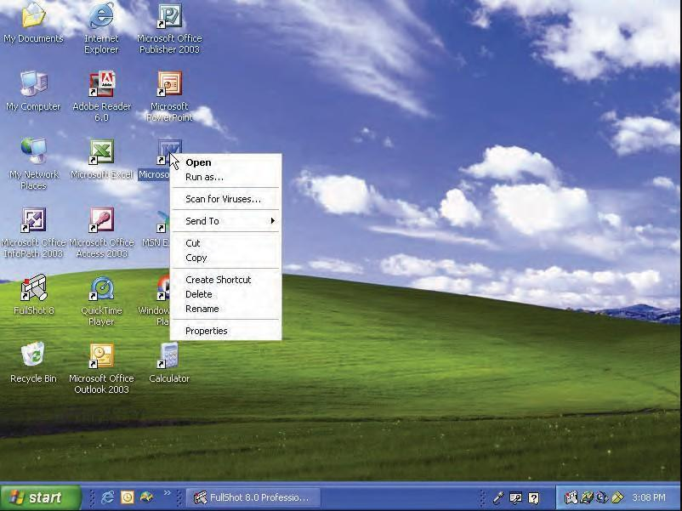

Task bar
icons
My Documents
Recycle Bin
Start button

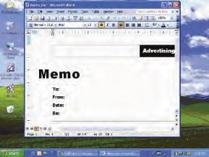
To maximize a window, or to make it fill up the screen, click the maximize button in the upper right corner of the window. To return the window to its original size, click the button again.

Scroll bar
Maximize bu
tton
All Employees
Human Resources August 30, 2012
Workshop Topics
Minimize button
You can minimize a window to take the window off the desktop without closing it. To minimize a window, click the minimize button in the upper right corner of the window.
Often, the entire contents of a window are not visible. To view the rest of the window, grab the scroll bar and drag it downward. The box that moves inside the scroll bar is called the scroll box.
To resize a window, or to make it larger or smaller, place the pointer over one of the corners of the window. When the small black arrows appear, drag the corner outward to make the window larger. Drag the corner inward to make the window smaller.
You can restore a window that was minimized to make it visible again. To restore a window, click the title of the window in the task bar. To close a window, click the Close Window button.
The Recycle Bin deletes files or applications from the computer. To delete a file or folder, drag the item to the Recycle Bin and drop it on top. This places the item in the Recycle Bin, but does not delete the item.
To delete the item, right click the Recycle Bin. Locate and click Empty Recycle Bin to permanently delete all of the items in your Recycle Bin.

Answer the questions on a separate sheet of paper.
Recall List three parts of the Windows desktop.
Reproduce Make a sketch of a window. On the sketch, label the following items: Maximize button, Minimize button, Scroll bar, and Title bar.

Working with Files and Folders

Windows Explorer is a program that shows the entire file system on a computer. To open Windows Explorer, you can choose Start>All Programs>Accessories>Windows Explorer.

Windows Explorer directory
parent directory subdirectory shortcut

At the top left of the window, click the Desktop icon. All of the files and folders on the desktop will be displayed on the right side of the window.
To sort the files and folders, open the View menu and choose Arrange Icons by. Then choose how you want to sort the files and folders.

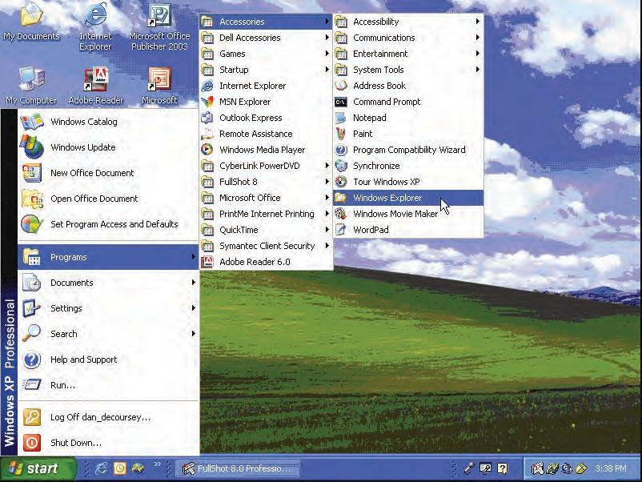

One of the directories, or containers for files and folders, on the desktop is called My Documents. To view the files of this directory, click the My Documents icon on the left. Files can be data, text, programs, and more.
A directory can hold other directories. A directory that holds other directories is called a parent directory. A directory that is located in another directory is called a subdirectory.

With so many places to look, finding folders and files can be difficult. Use the Search window to find files and folders when you do not know where they are.

If you are not sure if the name of a file is Computer, Computers, or Computing, use an asterisk for the part you are not sure about. For example, enter Comput* in All or part of the file name. This tells the computer to show all files that start with Comput.
To search for files or folders that contain the word computer, key computer below All or part of the file name. Then click Search.
To find out more about a file, right-click the file and choose Properties.

To search for a folder, you can choose Start>Search. To search all of the files and folders on the computer, click All Files and Folders on the left side of the Search window.
To search for files or folders that contain the word computer, key computer below All or part of the file name. Then click Search.

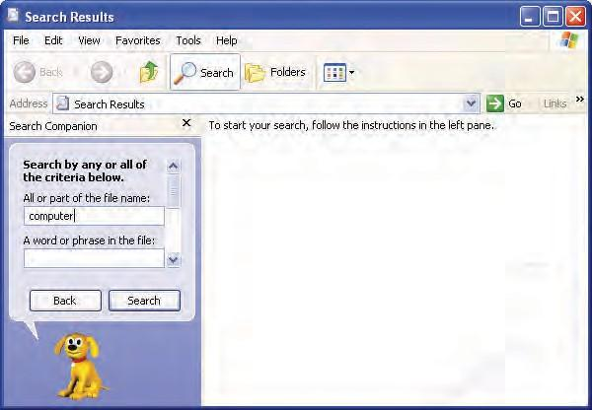

Search term

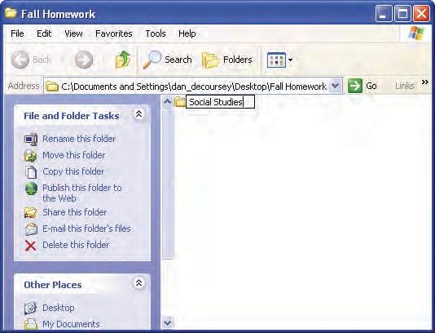
To create a folder, right-click the desktop. Then choose New>Folder. When the new folder appears, key Homework and press Enter on your keyboard. Right-click the Homework folder and choose Rename. Key Fall Homework. Press Enter.

New folder
To create a subfolder, open the folder in which you want to create the new folder. On the left side of the window, click Make a new folder. Finally, key Social Studies and press Enter.
Drag and drop Social Studies onto the desktop. Then drag it back into the Fall Homework folder.
To copy the Social Studies folder, right-click the folder and choose Copy. Then right-click the empty space in the window and choose Paste.
A shortcut is an icon that will automatically open a particular program, folder, or file, no matter where the shortcut is in the file system. Follow these instructions to create a shortcut:

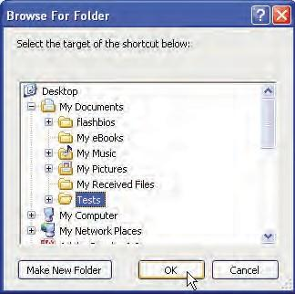
  - Right-click the place where you want to put the shortcut. Choose

New>Shortcut.
  - In the Create Shortcut box, click Browse.
  - Select the location of the program or folder to which you want the shortcut to lead. Click OK.
  - In the Create Shortcut box, click Next.
  - Key a name for the shortcut in the line at the top of the box. Click

Finish.

Answer the questions on a separate sheet of paper.

Describe Describe the relationship between a parent directory and a subdirectory.
Demonstrate Use the search function in Windows to search for files and folders.
Demonstrate Create a new shortcut.

Pathnames and File Compression

A pathname is a list of phrases that describes the location of a particular file. In a Windows Explorer dialog box, the pathname of a file appears in the Address window. The pathname includes the device letter (the storage device in which the file is stored), the folder, the subfolder (if a subfolder exists), the file name, and the file extension (which identifies the file type).

pathname
file compression
Note the pathname: C:\My Documents\Homework\Project01.doc. The parts of the pathname can be identified as follows:
Device letter: C: (C drive) Folder: My Documents Subfolder: Homework File name: Project01
File extension: doc (Word document)

If you are working on a network, you can send a pathname to a co-worker on that network so that he or she can find the file quickly.
You could send the pathname as a link that your co-worker can click to be taken directly to the file, or you could send the pathname as text and your co-worker will be able to use the pathname to find the document’s location on the network.
What can you do if your hard drive becomes full? The amount of memory that your computer has and how large your files are determine how many files will fit on your hard drive.
People who need to save large files often use file compression software. File compression is a process in which files are compressed, or “shrunk,” into a smaller file. The smaller file is called a compressed file. In order to open this file, you need to decompress it, or bring it back to its original size. A compressed file uses less disk space than a regular file. In fact, you can set a file compression ratio to determine how much your files will be compressed. For example, if you choose a file compression ratio of 20:1, the compressed file will be twenty times smaller than the original file.

Answer the questions on a separate sheet of paper.
Define What is a pathname?
Recall Identify the different parts of a pathname.
Explain What does a file compression ratio of 25:1 mean?

The Control Panel

The Control Panel contains tools that allow a user to change the way Windows appears and functions. To access the Control Panel, click Start>Control Panel.

Control Panel

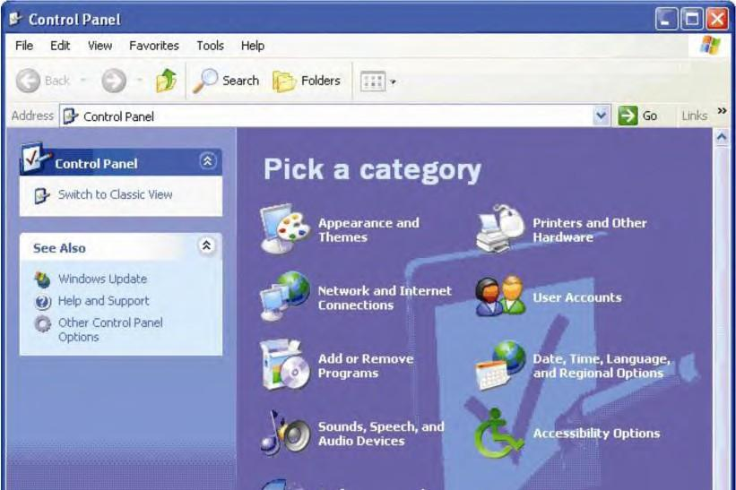

When you open the Control Panel in Category View, you will notice the following categories:

    - Appearance and Themes: This category includes the computer’s display settings, such as the computer’s theme, background, screen saver, and screen resolution.
    - Network and Internet Connections: You can use this category to change Internet connection settings or to create a connection to the network at your workplace.
    - Add or Remove Programs: This category, as its name indicates, is used to add or remove programs from your computer. When you click on this category, a window opens that includes all of the programs on your computer. You can remove these programs or make changes to them, such as modifying the default settings.
    - Sounds, Speech, and Audio Devices: Use this category to adjust your computer’s volume, to change the sound scheme (such as the sound that you hear when you turn on or shut down your computer), and to change speaker settings. You can also use this category to activate speech recognition devices.

    - Performance and Maintenance: In this category, you can free up space on your hard disk, back up data, or rearrange items on your hard disk to make programs run faster. You can also create scheduled tasks, such as scheduling an automatic backup on a daily or weekly basis.
    - Printers and Other Hardware: Use this category to install or add a printer or fax machine. You can also adjust settings for other hardware, such as game controllers, the mouse, the keyboard, and scanners.
    - User Accounts: This category is used to create a user account to use a computer or log onto a network.
    - Date, Time, Language, and Regional Options: In this category, you can change the date or time zone on your computer; change or add a language; and modify the format of numbers, dates, and times.
    - Accessibility Options: Use this category to configure Windows for special vision, hearing, and mobility needs.

Answer the questions on a separate sheet of paper
Identify Which Control Panel category would you use to add a speech recognition device?
Recall Name two settings you can change in the Appearance and Themes category.
Demonstrate Use the Control Panel to do the following:
Change screen displays.
Change mouse settings.
Change the date and time.

Shutting Down

It is a good idea to shut down and restart your computer from time to time. You may also put your computer in standby mode.

shut down restart standby

One benefit of this practice is that if security or virus protection updates have become available since you last shut down, you will receive notifications of these updates when you restart your computer. Shutting down your computer also saves electricity and can prolong the life of your computer.
To shut down or restart your computer safely, always use the Start menu. A computer should always be turned off by choosing Start>Shut Down.

After plugging the computer back in, you may need to wait for a longer time than normal for the computer to boot up while it performs system checks.
If the computer “freezes,” or does not respond to clicking the mouse, the Task List may be opened to view which programs are not running—these programs can then be cancelled. To access the Task List, simultaneously press CTRL + ALT + DELETE. When the Task Manager window appears, click the Task List and view the list of programs that are running. Select any program that is not responding, and then click End now. The program will be closed and may free up your computer. If this does not work, you may have to shut off your computer with the power button and then turn it back on. If this does not work, unplug the computer, and then plug it back in.
When you choose Shut Down from the Start menu, a Shut Down dialog box gives you the following options:

- Log off disconnects your account from the network without shutting down the computer. When you are connected to a network, it is always a good idea to log off when you leave the computer, or else the next person who sits at that computer will have access to all of your files.
- Shut down automatically logs you off the network. If no one else is going to use the computer after you, it is best to shut down the computer.
- Restart will shut down the computer, and then automatically start it again. You might need to do this when you install new software or if your computer is not working properly.

  - Standby lets your computer use less power when it is not in use. Your work stays on your computer so you can continue where you left off, but you should save it before you use this option.

When the Shut Down dialog box appears, click the drop-down arrow and choose Shut Down, if necessary. Click OK.

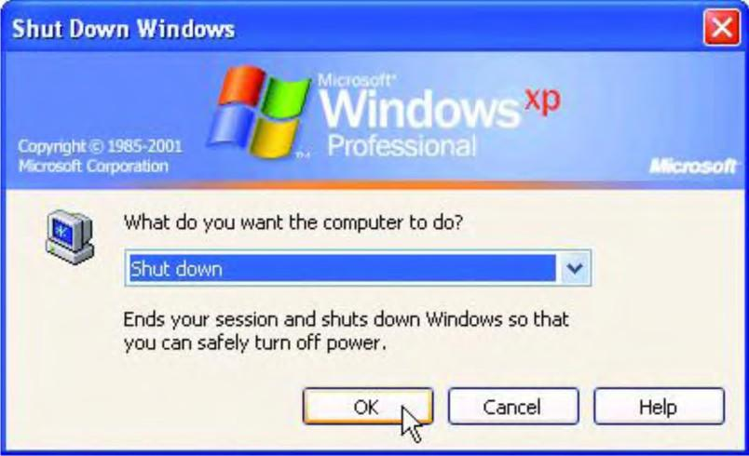

Answer the questions on a separate sheet of paper.
Recall Name one benefit of shutting down your computer.
Explain What does the Standby option do?
Discuss What is the first thing you should do if your computer freezes?

Using Help

Each Windows application includes a Help feature. The Help feature enables you to answer questions that are related to the particular application that you are using.

Help feature
Help and Support Center
For more general questions related to Windows, use the Help and Support Center, which is accessed by choosing Start>Help and Support. The Help and Support Center on Windows XP includes the following Help topics:

- What’s new in Windows XP?

- Music, video, games, and photos

- Windows basics

- Networking and the Web

- Working remotely

- Security and administration

- Customizing your computer

- Accessibility

- Printing and faxing

- Performance and maintenance

- Hardware

- Fixing a problem

- Send your feedback to Microsoft
In addition, you can research certain tasks, such as updating Windows, finding compatible hardware and software for Windows, and using Tools to diagnose problems. You can also search for Windows-related topics.
Microsoft.com includes information about both Microsoft Office and Microsoft Windows.

Microsoft Office Online (office.microsoft.com) presents troubleshooting tips and additional information for many applications, including Access, Excel, FrontPage, InfoPath, Live Meeting, OneNote, Outlook, PowerPoint, Project, Publisher, Visio, and Word.

Microsoft Office Online also offers many other features, including templates, downloads, and Clip Art.
Microsoft Windows Online (microsoft.com/windows) features information about all versions of Windows XP and Windows Vista. The Web pages for Windows XP and Windows Vista include many troubleshooting tips as well as free downloads and security updates.

Answer the questions on a separate sheet of paper.
Differentiate What is the difference between the Help feature and the Help and Support Center?
Predict Which help feature would you use to find information about how to save a Word document?
Discuss Name three types of information you could find at Microsoft Online.

- The is the visual representation of the file system on a computer.
- are graphic representations of files or applications.
- A(n) is a list of options.
- The shows what files and applications are open.
- The deletes files or applications from the computer.
- A(n) is simply a box that shows what is inside a folder or file.
- The box that moves inside the scroll bar is called the .
- A directory that holds other directories is called a .
- A directory that is located in another directory is called a .
- A(n) is an icon that will automatically open a particular program, folder, or file.
- A(n) is a list of phrases that describes the location of a particular file.
- The contains tools that allow a user to change the way Windows appears and functions.
- lets your computer use less power when it is not in use.
- The enables you to answer questions that are related to the particular application that you are using.
- To get help for general questions related to Windows, use the .
Concept Review

- Windows Explorer is a program that shows the entire on a computer.
- will shut down the computer, and then automatically start it again.
- Files that are “shrunk” into a smaller file are .
- If the computer “freezes,” or does not respond to clicking the mouse, the may be opened to view which programs are not running.

- To disconnect your account from the network without shutting down the computer, choose
.

Critical Thinking

- Design Design a file system to store information, such as homework, related to school. Sketch the file system with the highest directory at the top of the page. Use lines to show which folders are in each directory.
- Explain Write a paragraph in which you explain the different parts of a Windows desktop to someone who has never seen it before. Mention at least three parts of the desktop and explain what each part does.

The Graphical User Interface (GUI)

Once the computer has turned on, you will see the desktop. In a graphical user interface (GUI), the desktop is the visual representation of the file system on a computer. All of the files and applications on a computer can be accessed through the desktop. Icons are graphical representations of files or applications.

desktop icon
Start button Start menu menu taskbar
shortcut menu window maximize minimize scroll bar resize
restore Recycle Bin
The Start button opens the Start menu, which displays files and applications. A menu is a list of options. The taskbar shows what files are open and what applications are available as links. Right-click on the desktop to open a shortcut menu.
Double-clicking on a folder opens it. The contents of the folder are displayed in a window, which is a box that shows what is inside a folder or file. A different window can be opened for each file or folder you want to use.
To move a window, place your pointer on the Title bar. Press and hold the left mouse button and then move the pointer to where you want the window to be. Holding down the mouse button and moving the mouse is called dragging.

Icons

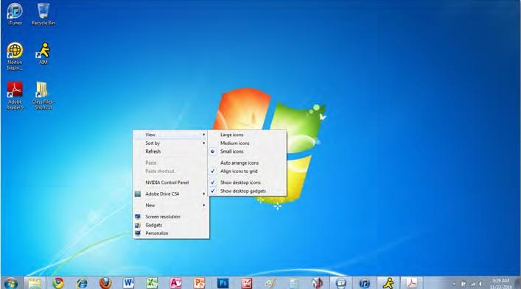

Menu
Start but
ton
Taskbar

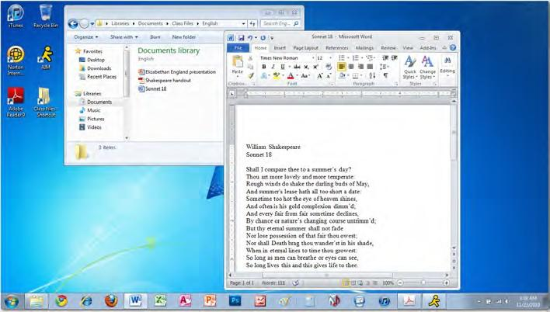
To maximize a window, or to make it fill up the screen, click the maximize button in the upper right corner of the window. To return the window to its original size, click the button again.

Maximize button
Minimize button

Scroll bar
You can minimize a window to take the window off the desktop without closing it. To minimize a window, click the minimize button in the upper right corner of the window.
Often, the entire contents of a window are not visible. To view the rest of the window, click on the scroll bar and drag it downward.
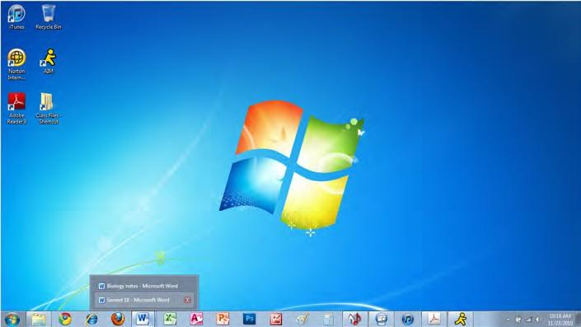
Sometimes, the box that moves inside the scroll bar is called the scroll box.

Recycle Bin

Minimized windows
To resize a window, or to make it larger or smaller, place the pointer over one of the corners of the window. When the double-headed arrow appears, drag the corner outward to make the window larger. Drag the corner inward to make the window smaller. To position a window on exactly half the screen, so you can work with two files side by side, click on the Title bar and drag the window all the way to the left or right.

You can restore a window that was minimized to make it visible again. To restore a window, click the icon of the appropriate program on the taskbar. Select the desired window from the list that appears, if necessary. To close a window, click the Close button.

Icons on the desktop can be arranged and rearranged to fit your needs you can click and drag icons to various places on the desktop. You can also right-click the mouse and choose Sort by. A submenu will open that allows you to arrange the icons by Name, Size, Item type, or Date modified.
The Recycle Bin deletes files or applications from the computer. To delete a file or folder, drag the item to the Recycle Bin and drop it on top. This places the item in the Recycle Bin, but does not delete the item.
To permanently delete all of the items in the Recycle Bin, double-click the Recycle Bin icon on the desktop. In the window that opens, click Empty the Recycle Bin. Click Yes.

Answer the questions on a separate sheet of paper.
Recall List three parts of the Windows 7 desktop.
Reproduce Make a sketch of a window. On the sketch, label the following items: Maximize button, Minimize button, scroll bar, and Title bar.

Working with Files and Folders

Windows Explorer is a program that shows the entire file system on a computer. To open Windows Explorer, you can choose Start>All Programs>Accessories>Windows Explorer, or you can simply right-click the Start button and select Open Windows Explorer. Alternately, you can click the Windows Explorer icon if it is pinned to the taskbar.

Windows Explorer directory
parent directory
subdirectory shortcut
At the top left of the window, click the Desktop icon. All of the files and folders on the desktop will be displayed on the right side of the window.
To sort the files and folders, click the More options drop-down arrow and select Details.

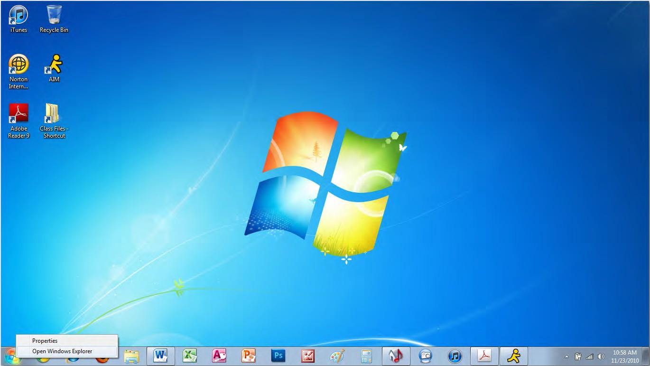

Open Windows Explorer

One of the directories, or containers for files and folders, on the desktop is called Computer. To view the contents of this directory, in Windows Explorer, with Desktop selected, double-click Computer. Files can be data, text, programs, and more.
A directory can hold other directories. A directory that holds other directories is called a parent directory. A directory that is located in another directory is called a subdirectory. For instance, Computer is a parent directory for DVD/CD-RW Drive (G:), and DVD/CD-RW Drive (G:) is a subdirectory of Computer.

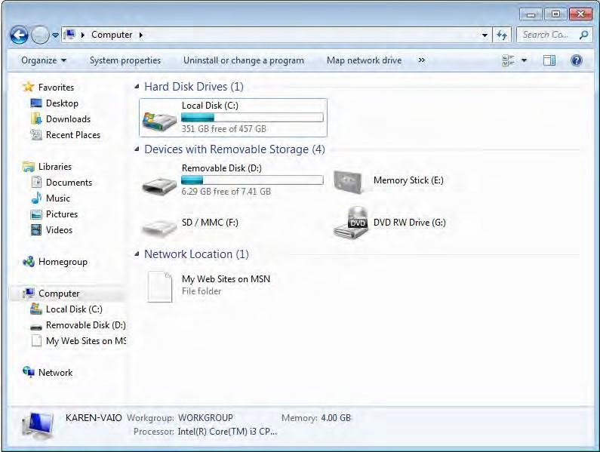

Desktop icon
More optio drop-down
ns arrow
DV
D RW Drive (G:)
Computer
With so many places to look, finding folders and files can be difficult. You can search directly from the Start menu. Click in the Start Search box on the Start menu and key in your search term. Windows 7 will instantly return results as soon as you start keying.
You can also launch Search by typing in the search box at the top of any open window or by pressing the

Windows key + F.

To find out more about a file, right-click the file and choose Properties.

Search results
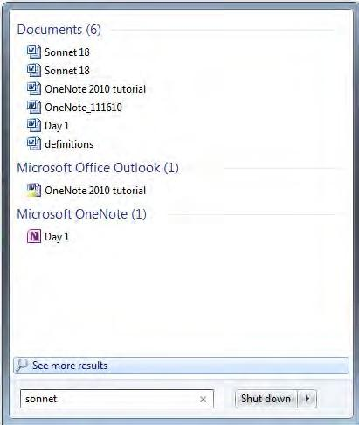
To view comprehensive, detailed search results, click See more results.

See more results

You can open a file from the Search Results window by double- clicking it.

If you are searching for a file, and you are not sure which form of a word is in the name (such as Computer, Computers, or Computing), key only the part of the word about which you are sure. For example, enter Comput in the Search box. The search results will show all files that start with Comput.

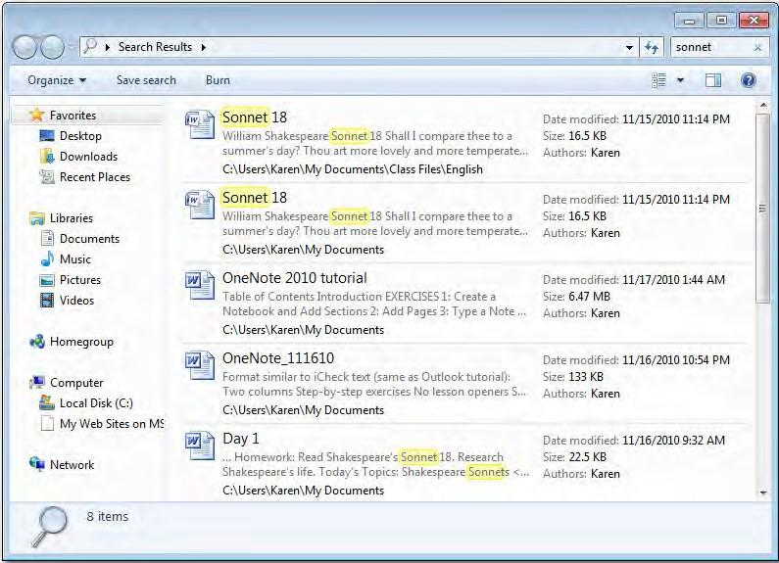

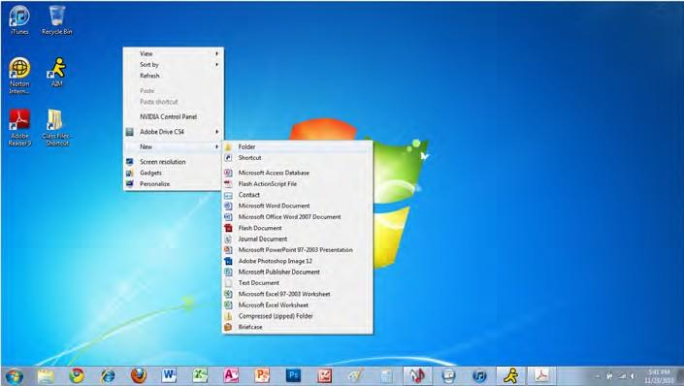
To create a folder, right-click the desktop. Then choose New>Folder. When the new folder appears, key Homework and press Enter on your keyboard. Right-click the Homework folder and choose Rename. Key Fall Homework. Press Enter.

To create a subfolder, open the folder in which you want to create the new folder (in this case, the Fall Homework folder you just created). Click New folder.
Finally, key Social Studies and press Enter.
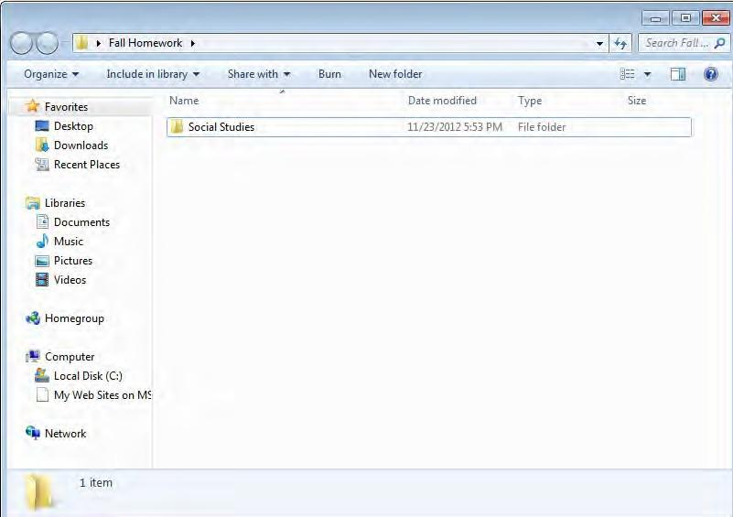
Drag and drop Social Studies onto the desktop. Then drag it back into the Fall Homework folder. To copy the Social Studies folder,

right-click the folder and choose Copy. Then right-click the empty space in the window and choose Paste.

To delete the copy of Social Studies, right- click the copy and choose Delete. Then click Yes in the Confirm Folder Delete box.

A shortcut is an icon that will automatically open a particular program, folder, or file, no matter where the shortcut is in the file system.
Follow these instructions to create a shortcut:

  - Right-click the place where you want to put the shortcut. Choose New>Shortcut.
  - In the Create Shortcut box, click Browse.

  - Select the location of the program or folder to which you want the shortcut to lead. Click OK.

  - In the Create Shortcut box, click Next.

  - Key a name for the shortcut in the line at the top of the box. Click Finish.

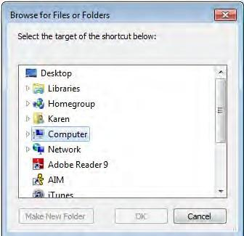
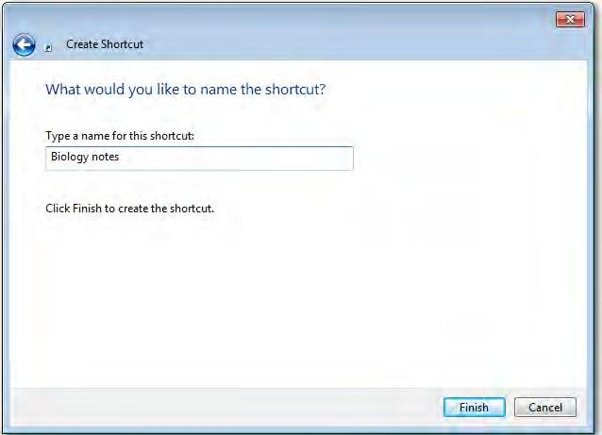

Target for shortcut

Name for shortcut

Answer the questions on a separate sheet of paper.
Describe Describe the relationship between a parent directory and a subdirectory.
Demonstrate Use the search function in Windows to search for files and folders.
Demonstrate Create a new shortcut.

Pathnames and File Compression

A pathname is a list of phrases that describes the location of a particular file.

pathname
file compression

The pathname includes the device letter (the storage device in which the file is stored), the folder, the subfolder (if a subfolder exists), the file name, and the file extension (which identifies the file type).
Note the pathname below: C:\Documents\Homework\Project01.docx
The parts of the pathname can be identified as follows:

Device letter: C: (C drive) Folder: Documents Subfolder: Homework File name: Project01
File extension: docx (Word document)
If you are working on a network, you can send a pathname to a co-worker on that network so that he or she can find the file quickly.
You could send the pathname as a link that your co-worker can click to be taken directly to the file, or you could send the pathname as text and your co-worker will be able to use the pathname to find the document’s location on the network.
In Windows 7, if you click to the right of the folder hierarchy in a window’s address bar, the traditional pathname appears. The pathname is automatically selected, to make it easy to copy (and paste in another location, if desired).

What can you do if your hard drive becomes full? The amount of memory that your computer has and how large your files are determine how many files will fit on your hard drive.

Popular file compression include Winzip, WinRar, Gzip, 7-Zip, and Stuffit. They have become so popular that many people use the product names to refer to the file compression process. For example, many call compressing a file “zipping,” and decompressing a file “unzipping.”
People who need to save large files often use file compression software. File compression is a process in which files are compressed, or “shrunk,” into a smaller file. The smaller file is called a compressed file. In order to open this file, you need to decompress it, or bring it back to its original size. A compressed file uses less disk space than a regular file. In fact, you can set a file compression ratio to determine how much your files will be compressed. For example, if you choose a file compression ratio of 20:1, the compressed file will be twenty times smaller than the original file.

Answer the questions on a separate sheet of paper.
Define What is a pathname?
Recall Identify the different parts of a pathname.
Explain What does a file compression ratio of 25:1 mean?

The Control Panel

The Control Panel contains tools that allow a user to change the way Windows appears and functions. To access the Control Panel, click Start>Control Panel.

Control panel

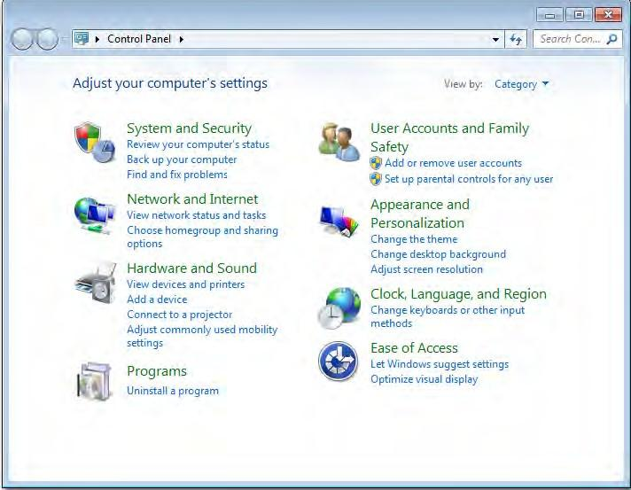

When you view the Control Panel by category, you will notice the following categories:

    - System and Security: In this category, you can choose when to be notified of changes to your computer, back up your computer’s files, and troubleshoot common computer problems. Network and Internet: You can use this category to change Internet connection settings or to create a connection to the network at your workplace.
    - Hardware and Sound: Use this category to install or add hardware, to adjust your computer’s volume, to change the sound scheme (such as the sound that you hear when you turn on or shut down your computer), and to change speaker settings.

      - Programs: This category, as its name indicates, is used to add or remove programs. When you click on Programs, and then Programs and Features, a window opens that includes all of the programs on your computer. You can uninstall these programs. You can also change the default settings for media and devices.

You can set the computer to use a larger font, to increase contrast, or to show a visual warning when the computer makes a sound.
      - User Accounts and Family Safety: This category is used to add or remove user accounts, change your Windows password, and set up parental controls for any user.
      - Appearance and Personalization: This category includes the computer’s display settings, such as the computer’s theme, background, screen saver, and screen resolution.
    - Clock, Language, and Region: In this category, you can change the date or time zone on your computer; change or add a language; and modify the format of numbers, dates, and times.
    - Ease of Access: Use this category to configure Windows for special vision, hearing, and mobility needs.

Answer the questions on a separate sheet of paper.
Identify Which Control Panel category would you use to add a speech recognition device?
Recall Name two settings you can change in the Appearance and Personalization category.
Demonstrate Use the Control Panel to do the following:
Change screen displays.
Change mouse settings.
Change the date and time.

Shutting Down

It is a good idea to shut down and restart your computer from time to time. You may also put your computer in standby mode.

shut down restart standby

One benefit of this practice is that if security or virus protection updates have become available since you last shut down, you will receive notifications of these updates when you restart your computer. Shutting down your computer also saves electricity and can prolong the life of your computer.
To shut down or restart your computer safely, always use the Start menu. A computer should always be turned off by choosing Start>Shut down.

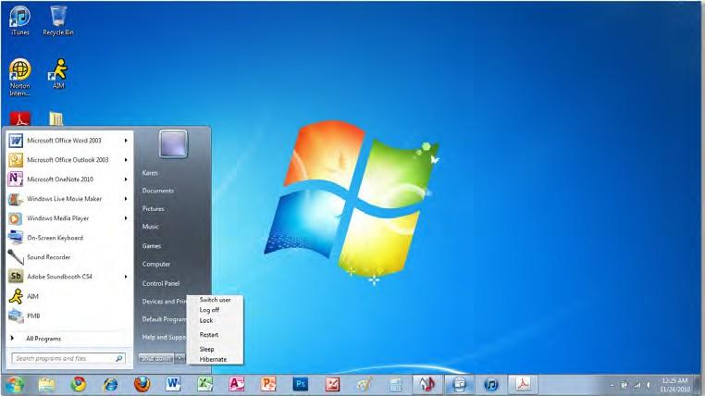

Shut down

If the computer “freezes,” or does not respond to clicking the mouse, the Task List may be opened to view which programs are not running—these programs can then be cancelled. To access the Task List, simultaneously press CTRL + ALT + DELETE and choose Start Task Manager. When the Task Manager window appears, click the Applications tab and view the list of programs that are running. Select any program that is not responding, and then click End Task. The program will be closed and may free up your computer. If this does not work, you may have to shut off your computer with the power button and then turn it back on. If this does not work, unplug the computer, and then plug it back in.

When you click the arrow next to Shut down in the Start menu, a shortcut menu appears with the following options:

    - Shut down closes all open programs, shuts down Windows, and then turns off your computer.

    - Switch user switches users without closing programs.

    - Log off closes programs and disconnects your account from the network without shutting down the computer.
    - Lock locks the computer. You will need a password to unlock the computer.

    - Restart closes all open programs, shuts down Windows, and then starts Windows again. You might need to restart when you install new software or if your computer is not working properly.
      - Sleep keeps your session in memory and puts the computer in a low- power state so that you can quickly resume working.

After plugging the computer back in, you may need to wait for a longer time than normal for the computer to boot up while it does system checks.
      - Hibernate saves your session and turns off your computer. When you turn on the computer, Windows restores your session. Hibernate lets your computer use less power when it is not in use.

Answer the questions on a separate sheet of paper.
Recall Name one benefit of shutting down your computer.
Explain What does the Sleep option do?
Discuss What is the first thing you should do if your computer freezes?

Using Help

Each Windows application includes a Help feature. The Help feature enables you to answer questions that are related to the particular application that you are using.

Help feature
Help and Support Center
For more general questions related to Windows, use the Help and Support Center, which is accessed by choosing Start>Help and Support.

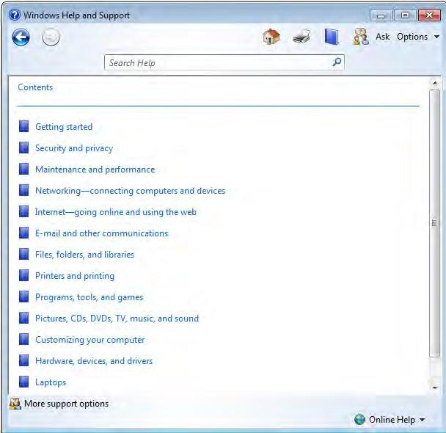

In addition to the main Help topics, you can research certain tasks, such as updating Windows, finding compatible hardware and software for Windows, and using Tools to diagnose problems. You can also search for Windows-related topics.

Microsoft.com includes information about both Microsoft Office and Microsoft Windows.

Microsoft Office Online (office. microsoft.com) presents troubleshooting tips and additional information for many applications, including Access, Excel, InfoPath, OneNote, Outlook, PowerPoint, Project, Publisher, SharePoint Workspace, Visio, and Word.
Microsoft Windows Online (microsoft.com/windows) features information about all versions of Windows 7. The Web pages for
Windows 7 include many troubleshooting tips as well as free downloads and security updates.

Microsoft Office Online also offers many other features, including templates, downloads, and clip art.

Answer the questions on a separate sheet of paper.
Differentiate What is the difference between the Help feature and the Help and Support Center?
Predict Which Help feature would you use to find information about how to save a Word document?
Discuss Name three types of information you could find at Microsoft Online.

- The is the visual representation of the file system on a computer.
- are graphical representations of files or applications.
- A(n) is a list of options.
- The shows what files and applications are open or available as links.
- The deletes files or applications from the computer.
- A(n) is simply a box that shows what is inside a folder or file.
- The box that moves inside the scroll bar is sometimes called the .
- A directory that holds other directories is called a .
- A directory that is located in another directory is called a .
- A(n) is an icon that will automatically open a particular program, folder, or file.
- A(n) is a list of phrases that describes the location of a particular file.
- The contains tools that allow a user to change the way Windows appears and functions.
- lets your computer use less power when it is not in use.
- The enables you to answer questions that are related to the particular application that you are using.
- To get help for general questions related to Windows, use the .

Concept Review

- Windows Explorer is a program that shows the entire on a computer.
- will shut down the computer, and then automatically start it again.
- Files that are “shrunk” into a smaller file are .
- If the computer “freezes,” or does not respond to clicking the mouse, the may be opened to view which programs are not running.

- To disconnect your account from the network without shutting down the computer, choose
.

Critical Thinking

- Design Design a file system to store information, such as homework, related to school. Sketch the file system with the highest directory at the top of the page. Use lines to show which folders are in each directory.
- Explain Write a paragraph in which you explain the different parts of a Windows desktop to someone who has never seen it before. Mention at least three parts of the desktop and explain what each part does.

E-mail, Instant Messaging, Discussion Forums, and Social Networking

The most popular form of online communication is e-mail, or electronic mail. E-mail is a system for sending messages and files electronically from one computer to another, enabling families, friends, business associates, and even complete strangers to communicate with one another. The messages can be text entered on the keyboard or files from a computer. All that is needed is an e-mail account, Internet access, and a Web browser or e-mail software, such as Microsoft Outlook.

e-mail
Microsoft Outlook distribution list instant messaging online chat
chat room discussion forum social networking
Outlook is a popular e-mail program that sends and receives e-mail, allowing you to share information with others anywhere in the world. It is also a desktop communications programs that helps you manage your time and information effectively. Outlook saves contact information, such as phone numbers and e-mail addresses, and has a calendar for scheduling. The
Outlook calendar is a useful time-management tool. You can view your schedule by the month, week, or day. The daily view allows you to schedule your time by the hour.
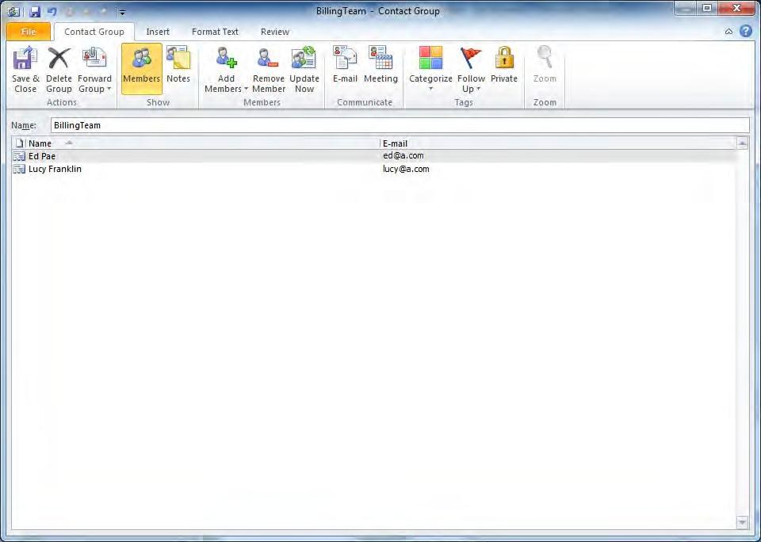
E-mail addresses function much like physical addresses do: they are used to identify the “mailbox” of the person to whom you are sending a message. E-mail addresses take on the following form: username@location. com. The username is the “address” of the person; the location is the “post office.” However, since many users often share the same location, avoiding duplicate addresses can be a problem. Perhaps you have tried to create a username with a popular e-mail provider such as Gmail, only to find that this name was already in use. To avoid this problem, create a username

MODULE 5
68
that is unique and meaningful to you.

In addition to e-mail, there are other types of online communication. A distribution list, or mailing list, is a list of e-mail addresses to which
e-mail messages can be sent. When an e-mail is sent to a mailing list, every
  - ail address on the list receives the e-mail. In Microsoft Outlook 2010, a distribution list is called a Contact Group.

Technology Handbook

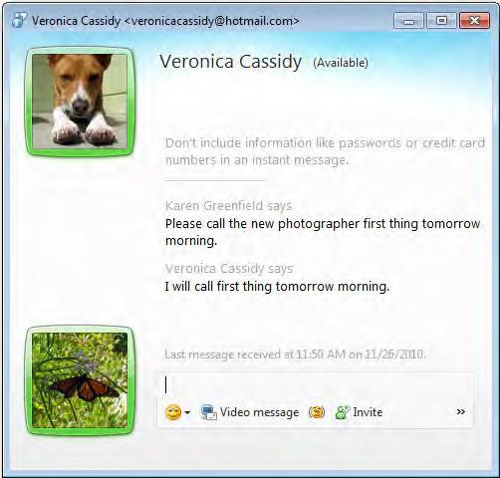
Instant messaging, another form of online communication, is like having a telephone conversation with text.

The person with whom you are communicating receives your messages as soon as you send them, and you receive their messages when they send them.
To some extent, instant messaging reduces the need for e-mail and long-distance phone calls. Most Internet providers offer instant messengers in which you can contact someone in real-time using his or her e-mail address.
Instant messaging is one tool for participating in online chat, which refers to conversations over the Internet between two people or a group of people. A chat room is a
web site, or a section of a web site, where users in different locations can have a real-time, onscreen group discussion by typing messages about a common topic of interest.
A discussion forum, also called an Internet forum or message board, is a web site that lets people have a virtual conversation by posting messages about a particular subject. A discussion forum may have the following hierarchical structure:

When more than one user responds to a discussion forum, the conversation is called a thread.

Forum
Subforum (category) Topic
Thread (subtopic) Reply
To read messages, you typically do not have to register or log in. To post messages, you might have to register and log in. Posted messages may or
may not need approval by a moderator before appearing in the discussion forum.

The first decade of the 21st century marked the rise of social networking web sites. A social networking site allows interaction among people who share social relationships, which may be personal or professional. Each user is typically represented by a profile, which may include photos as well as information about the person’s education, work, likes, and pastimes. Users may share thoughts, happenings, and interests with others in their network.
Some of the most popular social networking sites in the United States include the following:

    - Facebook

    - Twitter

    - MySpace

    - Friendster

    - LinkedIn

    - Foursquare
Other social networking sites are popular in other countries and regions of the world.

Most social networking sites offer privacy settings for controlling who can see what you share online.

Answer the questions on a separate sheet of paper.
Define Define e-mail.
Explain How are discussion forums and social networking sites different?
Use Send your teacher an e-mail explaining instant messaging.

E-commerce

E-commerce, or electronic commerce, is the buying and selling of products and services over the Internet. Consumers use e-commerce to shop for certain products without leaving their home;-they are able to search and pay for products that are delivered to their house. Businesses use e-commerce to reach more consumers, send information quickly, and have lower operating expenses.

e-commerce brick-and-mortar click-and-mortar click-and-order
business-to-consumer (B2C)
business-to-business (B2B)
consumer-to-consumer (C2C)
In its inception, e-commerce was not very popular among consumers. Only a small percentage of Internet users bought products online because many were concerned about security issues involving e-commerce, such as the theft of credit card numbers that were used to pay for products on the Internet. As businesses made their web sites more reliable, secure, and user-friendly, consumers began to experience the benefits of e-commerce. For example, shopping online allows consumers to quickly visit competitors’ web sites to compare prices of certain products. Online shoppers are also able to check the
inventory of a product, instead of going to a store only to find that the product they want is out of stock.

Businesses also reap many benefits from e-commerce. On the Internet, businesses are able to sell more products without the expense of hiring additional employees or opening new stores. E-commerce also makes it easier for businesses to keep track of sales and customer information.
There are several different types of e-commerce. Depending on how it uses the Internet, a company can be assigned to one of the following categories:

    - Brick-and-mortar businesses do not sell their products on the Internet. They might have a web site that describes their business, but they only sell products in physical locations.
    - Click-and-mortar businesses sell their products both on the Internet and in stores. Many clothing companies are click-and-mortar businesses.
    - Click-and-order businesses do not have any physical stores. They only sell their products on the Internet.
Different types of e-commerce transactions can be categorized as follows:

    - Business-to-consumer (B2C) e-commerce involves businesses that sell their products online to individual consumers. Most click-and-mortar and click-and-order businesses involve B2C
e-commerce.

    - Business-to-business (B2B) e-commerce refers to transactions in which businesses use the Internet

to sell products or services to other businesses, such as accounting services, business software, or production equipment.
    - Consumer-to-consumer (C2C) e-commerce involves one person selling a product to another person.
E-commerce does have some disadvantages, such as not being able to see the product with your own eyes, the increasing number of pop-up ads on web sites, and unsolicited e-mail from companies that engage in
  - ommerce. In addition, e-commerce could lead to a drop in jobs for sales clerks, store managers, and other employees who are no longer needed as the number of physical stores is reduced or even eliminated.

Answer the questions on a separate sheet of paper.
Summarize How do consumers benefit from e-commerce?
Identify Give an example for each of the following: brick-and-mortar, click-and-mortar, and click- and-order business.
Discuss Name two disadvantages of e-commerce.

Emerging Technology

Computer technology is constantly changing. Today, many workers carry a laptop PC, and a smartphone. With improvements in wireless technology, workers are able to work in many different places-the kitchen table, a park bench, or a lounge chair by the pool.

smart appliance smart house wireless technology nanotechnology
Smart appliances are appliances with computers that are connected to the Internet. Refrigerators could warn you when the milk is about to spoil, order more eggs for you, or schedule a repair visit. Microwaves could have an
Internet browser to search the Web for recipes. Many homes are equipped with technology that automatically monitors and adjusts lights, temperature, and TV or stereo volume. Smart houses could open doors automatically for an elderly or disabled resident. A smart house might include motion sensors to track movement-if they detect no motion for a certain amount of time, the house could call for help in case the person has fallen or lost consciousness.
Most of the existing and projected technological advances involve wireless technology. This technology relies on wireless zones, which allow people to access the Internet with wireless devices, such as laptops and smartphones. Wireless zones are available in many locations, such as airports, cafes, hotels, and convention facilities. For a small fee, or even for free, customers are able to “connect” to the wireless network without needing to plug into anything.
One of the major obstacles to the growth of wireless technology is security concerns. Currently, most wireless networks are not secure against hacking, since anyone with the adequate equipment can locate a wireless network’s signal, tap into it, and become a part of the network. From there, the hacker can do what he or she pleases. This security threat exists because wireless network transmissions can radiate in all directions. A wireless network’s signal may extend several hundred feet beyond the building in which it is used, allowing passersby to pick up the signal.
Some solutions to these security problems have been introduced. Wireless firewalls add an additional layer of protection, and encryption schemes convert the wireless network signals into a code that must in turn be decoded by someone else within the network in order to be decipherable. However, additional security measures are needed before wireless technology becomes the norm.
As security concerns regarding wireless technologies are addressed, the Internet relies less and less on physical connections. With greater, perhaps unlimited, bandwidth, the Internet is an even more valuable tool for communication and research.
One of the most discussed emerging technologies is nanotechnology, which involves the development of molecule-size supercomputers.

The application of nanotechnology will present various security as well as ethical concerns that will need to be resolved before it becomes commonplace.

The application of nanotechnology will present various security, as well as ethical concerns, that will need to be resolved before it becomes commonplace.
This technology may result in paper-thin computers that will roll up and fit in your pocket, or wearable computers that are built into clothing.
Eventually, doctors may be able to treat patients by injecting tiny robots that will single out and destroy diseased cells.

Answer the questions on a separate sheet of paper.
Define What is a smart appliance?
Create Draw a diagram of your own smart appliance. Label all of its features.
Predict Describe an invention that you think nanotechnology will make possible.

    - is a system for sending messages and files electronically from one computer to another.
    - The Microsoft Office software that sends and receives e-mail is .
    - A(n) is a list of e-mail addresses to which e-mail messages can be sent.
    - A(n) is an online discussion group, or a group of individuals on the Internet with a common interest in a particular subject.
    - A(n) site allows interaction among people who share social relationships, which may be personal or professional.
    - is like having a telephone conversation with text.
    - , or electronic commerce, is the buying and selling of products and services over the Internet.
    - businesses do not sell their products on the Internet; they only sell products in physical locations.
    - businesses sell their products both on the Internet and in stores.
    - businesses do not have any physical stores; they only sell their products on the Internet.
    - e-commerce involves businesses that sell their products online to individual consumers.
    - e-commerce involves one person selling a product to another person.
    - Appliances with computers that are connected to the Internet are called .
    - relies on wireless zones to allow people to access the Internet with wireless devices.
    - involves the development of molecule-size supercomputers.
Concept Review

    - Like physical addresses, function to identify the “mailbox” of the person to whom you are sending a message.

    - The is used to distribute newsfeeds to newsgroups according to their subject of interest.
    - ads on web sites are one disadvantage of e-commerce.
    - Smart houses will have networks that control appliances.
    - One of the major obstacles to the growth of wireless technology is concerns.

Critical Thinking

    - Explain Write a paragraph in which you explain how you think e-mail has changed the way people do business and communicate.
    - Predict Name three additional features that a smart house might have.

Ethics and Technology

the right thing:
Computers can be used to do wonderful things. They can be used to complete homework assignments and workplace projects, as well as keep friends and family in touch with one another. However, they can also be misused.
Knowing some simple ethical guidelines will ensure that you are always doing

digital paper trail plagiarism

      - Because your school may have a fast Internet connection, you may be tempted to use these connections to download large files. Check with your teacher first, as there may be policies forbidding this.
      - E-mail systems leave a “digital paper trail.” This means that what you type into an e-mail can be found by a system administrator. Be sure not to abuse company or school e-mail systems.
      - Avoid plagiarism, or taking somebody else’s ideas and passing them off as your own, whether it is one or two sentences or an entire term paper. The “cut-and-paste” feature built into modern software makes a lot of mundane tasks, like moving a paragraph of text, quick and easy—but also makes plagiarism all too easy. Be on guard against falling into this trap.
It is acceptable to quote online sources in your work, but you must make sure you identify those sources and give them proper credit.
Also, some web sites do not allow you to quote from them. Check each site or resource you are quoting to make sure you are allowed to use the material.
      - You would not steal office supplies from your office or school, so make sure you do not take home computer-related resources like CD-ROMs.
      - It is not legal to download copyrighted music and videos and share them for free. Only use legal file sharing sites, which usually charge a small fee.
      - Follow copyright laws. If you want to use part of an online work that has been copyrighted, contact the Webmaster of the site or the author of the article to request permission.
      - Evaluate the information listed in a web site carefully. Be sure each site is relevant, reliable, recent, and verifiable.
Whether in the classroom or at the library, you likely spend time working at a computer. Remember that the computer is there to help you get your work done. If you instead use the computer to play games, check your personal e-mail, or look at offensive material on the Internet, you are inappropriately using the resource that is being provided for you and others.

Many institutions are taking action to prevent such misuse. Hidden software applications watch everything users do while they are on a machine, including which web sites they visit, what e-mails they send, even what keystrokes they key. If you are engaging in inappropriate activity on a school computer, you could be suspended from school, or perhaps even prosecuted.

A good guideline to keep in mind: Do not do anything on a computer that you would not do if your teacher or parents were standing behind you, watching.
While it might seem harmless to do a few small personal tasks while you are at work, the costs really do add up.
Billions of dollars are wasted in American businesses every year due to personal use of company computers. These losses can be eliminated if
computers are only used for business purposes.

Answer the questions on a separate sheet of paper.
Explain What is a “digital paper trail”?
Predict When is it acceptable to quote from someone else’s work?
Analyze Why do you think music companies are trying to stop illegal downloading of music files?

Copyrights and Wrongs

A copyright protects someone who creates an original work. When you create something—a book, a play, or a single sentence—you can copyright it, thereby claiming that you created it and you are the owner. The goal is to prevent unauthorized copying of that work by another party.

copyright
Copyright Act of 1976 permission
public domain derivative works fair use
Copyright protection is provided by the Copyright Act of 1976, a federal statute.
At one time, if you wanted to copyright something you had to fill out a form, file your work with the Copyright Office in the Library of Congress, and pay a fee. Today, this is no longer the case. If you create an original work, it is
automatically protected by copyright law—even if you forget to put the “© [year]” marker on the document. However, registering a copyright with the office does provide some additional protections, should you ever have to go to court over your creation.
What do you do if you want to use a portion of a copyrighted work in your own work? You need to obtain
permission, or authorization to do so, from the copyright holder.

Obtaining permission depends on the work in question. If you want to use an excerpt from a book, you will need to write a letter to the publisher, since it is the owner of the copyright. Each instance is different, but many publishers are willing to grant permissions to individuals for educational purposes. If you want to reproduce information you found on the Web, contact the Web administrator or author of the article to request permission. Always ask permission to use the content that has been developed by someone else. In many cases, permission is granted for free use although sometimes a fee is charged to use the content.
Once a copyright is in place, how long before it expires? The answer depends on when the work was created. For all works created since January 1, 1978, copyright lasts until 70 years after the creator’s death. For works created before that date, the answer is considerably more complex. The copyright would last anywhere from 28 to 67 years from the date of creation, with possible options for renewal.
Once a work’s copyright has expired, that work is considered to be in the public domain, meaning that nobody owns it and anybody can reprint it as they please. This is why you can find so many different printed versions of classic literature from writers like Dickens, Shakespeare, and the like—the publishers do not have to pay any fees for the right to print those books. Now, one can read for months on end the complete collection of Shakespeare!
It is important to remember that although public domain material is free to use, it is still necessary to cite the source of the material. In addition, if you are unsure about whether it is necessary to ask for permission to use intellectual property, it is best to ask for permission to make sure you avoid violating copyright laws.

Following are some common misconceptions about copyrights:

      - “If it does not say it is copyrighted, it is not copyrighted.” Original work published after March of 1989 is copyrighted, whether it says so or not.
      - “I found it on the Internet, therefore it is okay for me to copy it.” Most of the text on the Internet is indeed copyrighted. Copying information from the Internet is a serious breach of copyright, and can result in prosecution.
      - “It is okay to put copyrighted material on my web site, because I do not charge people to look at it.” It does not matter whether you are making a profit from the reuse of copyrighted material—you are distributing it, and that is illegal.
      - “I have changed the material, so it is no longer copyrighted.” Copyright law says that only the owner of the copyright can make “derivative works”—that is, new works based on the existing material. This law allows only the owner of the copyright to profit from the intellectual property.
        - “I can reprint the material, because it is considered fair use.” Be careful! Fair use refers to the right to reprint brief excerpts from copyrighted works without obtaining permission. However, there are no clear definitions on how much of a work can be used. Some examples of the fair use doctrine include quoting a book or part of a book in a book report or parodying a work. The purpose and character of the use must be considered.

Under fair use, educational purposes are sometimes considered acceptable, such as when teachers copy a few pages of a book to hand out to students to teach a lesson.

Answer the questions on a separate sheet of paper.
Recall What is a derivative work?
Analyze Give an example of a fair use of copyrighted material.
Identify Name a work that is in the public domain.

Netiquette

New rules of etiquette have evolved for the new online communication media provided by the Internet: e-mail, chat rooms, discussion forums, and social networking sites. Nicknamed “netiquette,” the basic guidelines described here are important to keep in mind whenever you are communicating with someone online.

netiquette spam flame

E-mail

Of all the conveniences provided by the Internet, e-mail is the most widely used. It has changed how people live, work, and socialize. Letters that used to take days to arrive in the mail now take mere seconds. Business communication has become much more efficient thanks to e-mail. Here are a few things to keep in mind when sending e-mail:

      - Make a good impression in your e-mail communications. Be clear and concise. Keep all your responses in context. Proper spelling, capitalization, and grammar are as important in e-mail as they are in the papers you are writing for your English classes!
      - Do not send large attachments, unless the recipient is expecting them. Be sensitive to the time that it takes to download an attachment on different computer configurations.
      - When forwarding e-mails, trim off unnecessary information like old headers and quotes—these can build up quickly! Delete the e-mail addresses for prior forwarded names.
      - Do not say anything about someone that you would not want them to hear. Even after you click Delete, e-mail records stay in the system for a long time.
      - Never send or forward chain letters. Even if they seem like a good idea, they are often fraudulent.

      - Do not “spam.” Spam, or junk e-mail, is a billion-dollar problem, clogging e-mail systems and wasting time. Spam floods the Internet with many copies of the same message.
      - Do not SHOUT. It is difficult to convey emotion in e-mails. Avoid using capital letters. All capital letters can be considered rude. Make sure your Caps Lock key is off.

Chat Rooms

Chat rooms can be useful communication tools, but they can also be raucous free-for-alls. Look for sites that include procedures and guidelines that contributors must follow. Some things to keep in mind:

      - Choose the chat room wisely. Some chat rooms have questionable people, so do some research first.

      - Behave as though you were communicating face-to-face. Remember that words can be misinterpreted, and things like sarcasm and body language may not come across online.
      - Do not threaten, harass, or abuse any participants in a chat room. Treat people online exactly as you would treat them in person.
      - Take turns with the conversation. Just like in a real conversation, allow people to finish their thoughts, and do not interrupt.
      - Be aware of “lurkers,” people who are reading the conversation but not taking part.

Discussion Forums

Having a rewarding experience with a discussion forum requires some basic netiquette, including the following guidelines:

      - Join discussion forums that have rules for participation.

      - Stay on topic. Most discussion forums are very specific, and readers do not appreciate posts (contributed information) that do not fit the topic.
      - Do not “flame.” A flame is an aggressive or insulting letter. People in discussion forums often get passionate or excited in these conversations, which make it easy to flame. Respect the opinions of others. Never say something that you would not want to say out loud.
      - Know your facts. There is no fact-checking process in discussion forums. Just because somebody makes a statement does not mean it is true. Remember this when quoting or replying to someone.

Social Networking Sites

Social networking sites can provide an excellent way to keep in touch with friends and colleagues. Here are some guidelines for proper usage:

      - Do not post information, pictures, or videos that you would not want your employer, teacher, parent, or other group or individual to see.

      - Be aware that public information you post might be monitored by your current employer or by a potential employer (such as when you apply for a job).
      - Do not expose sensitive or private information about your employer or classmates.

      - Do not use social networking to damage the reputation or character of a person or business.

      - When making posts, use good judgment and consider your audience.

      - Do not let your productivity at home or at work suffer because you spend too much time on social networking sites, especially playing games.

Behave online as you would in the real world—honestly, ethically, and wisely.

Answer the questions on a separate sheet of paper.
Define Define “netiquette.”
Summarize What are some general “netiquette” rules?
Analyze Why do you think it is bad netiquette to send large files to someone who is not expecting them?

Staying Safe Online

The Internet can be a wonderful place. There is much to learn, explore, and discover. Through the Internet, you can stay in touch with friends and relatives and meet new friends who share your interests. While the Internet helps communications, spending a lot of time at computers can

identity theft phishing

also isolate people. It is important to balance the time you spend online with other activities.

The Internet is widely used in personal, school, and business settings. In each of these settings, there is a set of formal and informal rules that online users must follow. Following such rules will keep you safe online.
Information is valuable. Companies that operate on the Internet are constantly seeking more information about customers, as well as potential
customers. By building vast databases of names, addresses, and information about buying habits, those companies can market their products and services with increased efficiency, thereby increasing sales.
But in addition to legitimate sites that ask you for information like name, address, or age, there are many questionable sites that are looking for data as well. Before you key any information into an online form or in a chat room, be sure to evaluate to whom you are sending that information and why you are sending it. When you are online, remember people may not be who they seem.
Identity theft is a crime in which someone takes your personal information—such as your name, address, social security number, driver’s license number, date of birth, or mother’s maiden name—and uses it to establish credit and charge items to you. In some cases, identity thieves arrange to have mail, such as a credit card bill set up in your name, sent to their house so that you are not aware of the charges that you owe until someone investigates your credit history.
In many business transactions, such as renting an apartment or securing a car or home loan, the owner or banker runs a credit check to see if you have any debt that you have failed to pay. Imagine your surprise when

you find out that you owe thousands of dollars on a credit card that you never applied for! Not only will you have to prove that you were the victim of identity theft to avoid paying the debt, but you will also be unable to rent an apartment or buy a car or house until you clear your credit history.

Be aware of scams intended to steal your personal information.
In the past, identity thieves scavenged victims’ trash for credit card bills or other correspondence with personal information that can be used to establish
credit. With the Internet, thieves no longer need to dig through your trash. They use the Internet to solicit the information from you. If you come across one of the following Internet scams, report it immediately to an adult:

      - “Phishing” is a scam in which an identity thief sends you an e-mail in which he or she pretends to be a representative from a company with which you do business. For example, you might receive an
e-mail that is supposedly from your bank or Internet provider that asks you to provide personal information to update your account.
      - Some identity thieves send e-mails in which they claim that they are from a foreign country and they need help transferring money to the United States. They ask for your bank information and promise that they will pay you for your assistance.
      - Ironically, some people have actually received e-mails from companies that claim to offer identity theft protection and credit repair. However, after they send their personal information, they find out that those who sent the e-mail were quite the opposite.
      - The “You won a prize!” scam is increasingly common. This scam involves receiving an e-mail that indicates you have won a prize, perhaps a trip or a lot of cash. Of course, you must provide your personal information in order to receive the prize.

In order to avoid these scams, always keep in mind what people really need to know to complete a transaction. For example, when you call your bank, the banker often asks for your mother’s maiden name because he or she needs to verify your identity. However, if someone claiming to work for your bank calls or e-mails you, he or she has no need to know any information already included in your bank file. Clearly, this person has contacted you only to solicit your personal information.

If you are still unsure whether it is safe to give the information, check with a parent or other trusted adult.

To stay safe online, take the following precautions:

      - Know to whom you are giving the information. Check the URL in your browser. Does it match the domain you visited? Or were you redirected to another site without your knowledge?

      - Why are you giving the information? For example, if you are ordering something online, you will need to give your address in order for the product to be shipped. There should always be a good reason for all the information you provide.
      - Never give out your social security number, your birth date, or your mother’s maiden name without adult consent. This information is often used to secure credit reports, and giving this information to a dishonest source can ruin your credit.
      - Never give personal information of any sort to someone you meet in a chat room. Always remain anonymous.
      - Never give your password to anyone. Even if you call your Internet provider’s help support, you should not have to provide your password.

Answer the questions on a separate sheet of paper.
Define What is “phishing”?
Predict What information will you need to give if you order something online?
Discuss Write a paragraph that discusses the dangers of the Internet.

- Be sure not to abuse company or school e-mail systems, as e-mail systems leave a(n)
.

- Taking somebody else’s ideas and passing them off as your own is called .
- A(n) protects someone who creates an original work.
- Copyright protection is provided by the , a federal statute.
- If you want to use a portion of a copyrighted work in your own work, you need to obtain
from the copyright holder.

- Once a work’s copyright has expired, that work is considered to be in the , meaning that nobody owns it and anybody can reprint it as they please.
- A(n) is a new work based on existing material.
- refers to the right to reprint brief excerpts from copyrighted works without obtaining permission.
- New rules of etiquette that have evolved for the new communication media provided by the Internet are called .
- , or junk e-mail, is a billion-dollar problem, clogging e-mail systems and wasting time.
- A(n) is an aggressive or insulting letter.
- is a crime in which someone takes your personal information and uses it to establish credit and charge items to you.
- is a scam in which a person sends you an e-mail in which he or she pretends to be a representative from a company with which you do business.
Concept Review

- If you quote online sources in your work, you must identify those sources and give them proper
.

- If you want to reproduce information you found on the Web, contact the or to request permission.
- Never send or forward . Even if they seem like a good idea, they are often fraudulent.

- Make sure your Caps Lock key is off to avoid .
- To have a rewarding discussion forum experience, stay on .
- Today’s identity thieves use the to solicit the information from you.
- Make sure the URL in your browser matches the domain you visited and that you were not
to another site without your knowledge

Critical Thinking

- Predict Think of three types of businesses that you think rely on copyright laws to protect their assets and make their business more profitable. Write down the type of business and then describe how copyright laws could help that type of business.
- Compile Create a checklist of Internet scams you learned about in this module as well as any you have heard about or seen on your own. You can place your list next to your computer as a reminder for staying safe online.

Using the Internet

Computers connect to the Internet in different ways. Homes and businesses pay an ISP, or Internet Service Provider, to connect to the Internet. A modem connects a computer to the Internet. As you will learn later in this module, dial-up modems and DSL modems use phone lines to connect to the Internet. A cable modem uses cable TV wires to connect to the Internet. A browser is the software that sends and retrieves information on the Internet. Study the figure below to learn about some important browser functions.

ISP
modem browser hyperlink
multimedia page search engine
A hyperlink is an item on a Web page that links to another Web page. The image to the right shows hyperlinks to pages containing details about news and events.

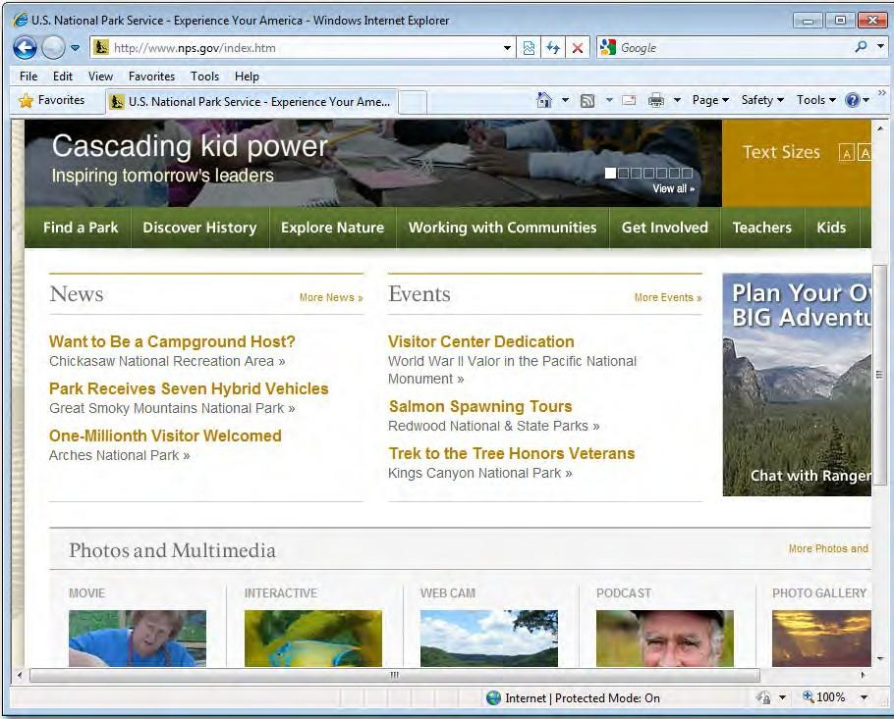

Hyperlinks
Hyperlinks

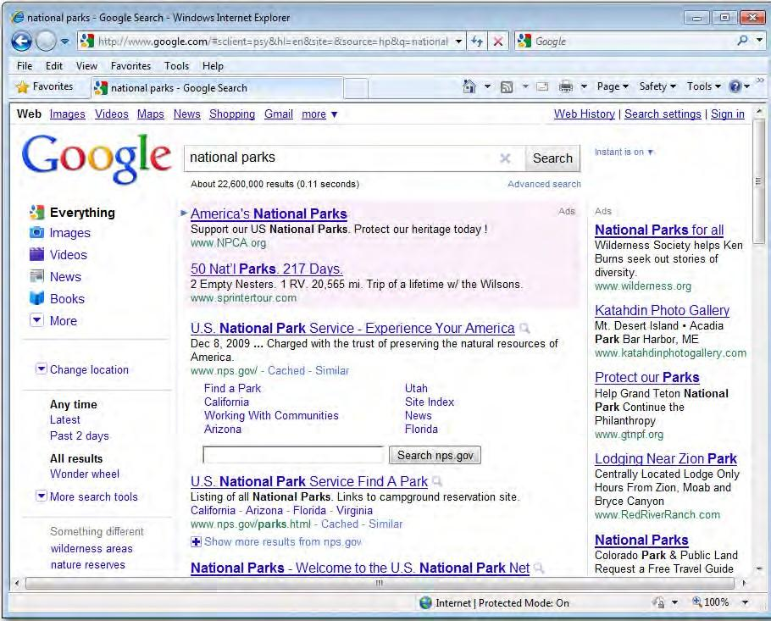
Web browsers let you bookmark pages, which are called Favorites in Internet Explorer. A bookmark sends the browser automatically to a page that you specify. Web pages that contain information in many forms, like sound and movies, are called multimedia pages.

The Internet contains so much information that it is often hard to find what you are looking for.
Search engines search the Internet for keywords that you provide.
Popular search engines include Google, Yahoo!, Bing, and Ask.
Regardless of which search engine you use, it is important for you to be able to search effectively.

Answer the questions on a separate sheet of paper.
Define What is a browser?

Explain Why are bookmarks useful?

Compile Make a list of five of your favorite multimedia pages on the Internet.

Speed on the Internet

Internet speed is determined by the type of modem and Internet connection that you have. In general, the more expensive the modem and Internet service, the faster the Internet connection.

telephone modem dial-up connection POTS
DSL modem cable modem satellite modem
The slowest, and least expensive, type of modem is a telephone modem. This type of modem uses a dial-up connection, meaning that it uses telephone lines to connect to the Internet. A dial-up connection relies on what is sometimes referred to as POTS, or Plain Old Telephone Service.
Due to high Internet traffic on phone lines as well as the limitations of a telephone modem, dial-up connections are quite slow. To be exact, a telephone modem has a speed of 56 kbps (56 thousand bits per second).
The digital family of modems and Internet connections are much faster and more prevalent. Digital modems use digital signals, instead of the analog signals used by POTS, to send and retrieve information over the Internet. Digital signals are much faster and more efficient than analog signals—digital modems can be from 20 to 100 times faster than a telephone modem, enabling not only higher speeds but also greater access to
multimedia Web pages. High-speed Internet is sometimes called broadband. It transmits data at a rate of at least 256 kbps. The three major types of digital modems are discussed below:

DSL stands for “Digital Subscriber Line.”

  - A DSL modem, like a telephone modem, uses telephone lines to connect to the Internet. However, a DSL connection is different than a dial-
up connection in several ways: a DSL connection is always on, so there is not a need to dial in to connect; a DSL connection uses digital technology that is much faster than POTS; and the digital signals that a
DSL modem sends and receives do not interfere with telephone service, so you can make and receive phone calls while connected to the Internet.
- A cable modem uses a TV cable to connect to the Internet. Many of its advantages are similar to those of a DSL modem: its processing speed is much faster than a telephone modem; the connection is always on; and although a cable modem transmits signals on a TV cable, the Internet connection does not interfere with cable TV service.
- A satellite modem, as its name suggests, uses a satellite dish to connect to the Internet. Some cable TV companies now provide small satellite antennas that enable you to both connect to the Internet and receive cable TV. As is the case with cable modems, a satellite modem is much faster than a telephone modem, its connection is always on, and it does not interfere with cable TV service.

Wireless ISPs deliver Internet service using wireless technology. Wireless Internet service uses radio frequencies and other signals to link locations and transmit data. Wireless LANs (local area networks) are popular in homes, providing Internet access to laptops and other devices. Businesses, services, and even cities may provide wireless Internet access to users in the immediate area, often free of charge.
Mobile broadband offers a wireless Internet connection but does not confine the user to a particular area. Service may be provided through a portable modem, PC card, mobile phone, or other device.

Answer the questions on a separate sheet of paper.
Recall What does POTS stand for?

Discuss What is the data transmission rate of high-speed internet?

Predict How might a person on a business trip take advantage of wireless Internet access?

Techniques for Searching

The Internet is probably the single most important tool for research. However, the advantage provided by the Internet can also be its greatest challenge: There is so much information out there that it is difficult to know where to begin!

keyword Boolean logic
Boolean operators
A good place to begin work regardless of your research topic is Google.
Arguably the most useful search engine, Google is an enormous “spider” (an automated piece of software that “crawls” the Web looking for information) that keeps an index of over three billion URLs. Simply type your topic into Google’s search bar.
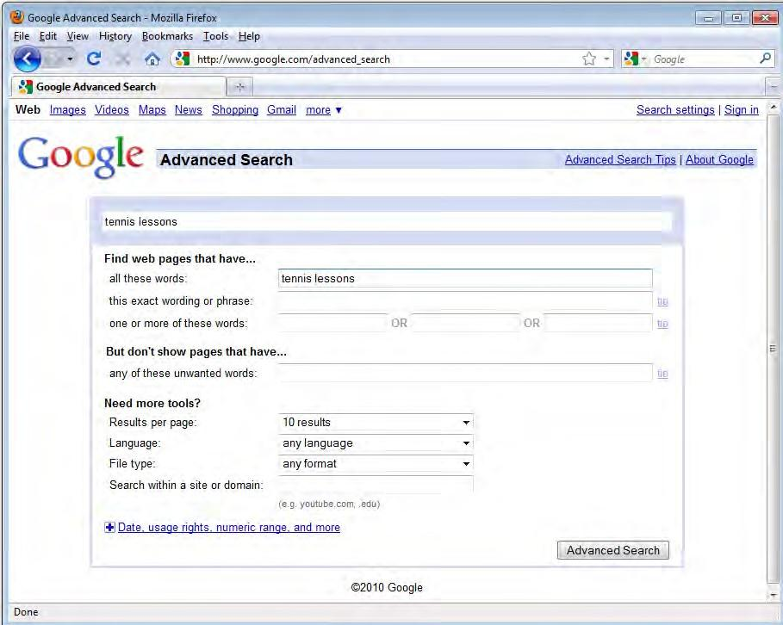
When you use the Internet for research, you want to find Web pages that contain useful, or relevant, information. The first step towards finding this information is choosing appropriate keywords.

Keywords are the words a search engine uses in its search for relevant Web pages.
If you use only one keyword to search the Web, you may find that you get a very high number of results, most of which are irrelevant. For example, if you want to find information about tennis lessons, a general keyword such as tennis might produce results as varied as tennis-related products, the history of tennis, tennis rankings, tennis clubs, and tennis lessons. To avoid sifting through irrelevant links, use the more specific phrase tennis lessons.
Many search engines also have an advanced search that allows you to indicate exactly what you want the engine to search for and what you want it to ignore.
Boolean logic, named after nineteenth-century mathematician George Boole, is a form of algebra in which all values are reduced to TRUE or FALSE. This logic system can be applied to search engine keywords in order to find only the most pertinent results.

Boolean operators, or the conventions used in keywords to apply Boolean logic to Internet searches, are as follows:

- To find Web pages with an exact phrase, place the keyword or phrase in quotation marks. Phrases in quotation marks such as “Boston terriers” and “Siamese cats” will only produce Web pages that include that exact phrase.
- You can search for Web pages that include two or more keywords, although the words will not always be near each other on the Web page. To do such a search, use the following Boolean operators: AND,
+, &. You can also simply include a space between words. The following are examples: cats AND dogs, cats & dogs, cats + dogs, cats dogs. These phrases will only produce Web pages about both cats and dogs.
- To search for Web pages with one or both keywords, use the following Boolean operators: OR, ^. Examples of keywords with these Boolean operators are lizards OR snakes, lizards ^ snakes. These phrases will produce Web pages that refer to lizards, snakes, or both.

On Google, after you have entered your search phrase and have finished looking at the results, click on the “News” tab near the top of the page. This will show you recent news stories about your topic from a number of news services and wires.
  - To find results with one but not another keyword, use the following Boolean operators: NOT, -. Examples are cats NOT tigers, cats -tigers. These phrases will produce results about all cats except tigers.
  - If you are looking for a combination of specific information, you can use a combination of Boolean operators, such as “pet care” + lizards OR snakes. This phrase will produce Web pages about pet care for lizards or pet care for snakes.
  - If you only want to find information from a specific web site, just add the domain after the search term along with the ?site? tag, and the search engine will only look for documents on that site: ?pet care? site: www.humanesociety.org.

To search for Web pages where your keywords do appear near one another, use NEAR. Entering cats NEAR dogs will return sites that contain both words and have the two words close to one another.

Your Web searches will likely give you page after page of hits, each with a brief summary of some of the text from that page. Some things to think about while browsing your results:

- Links on the right-hand side of the page (and sometimes at the top, in a colored box) are sponsored links—this means that the company in question has paid to have its link show up. While this does not necessarily mean that the link is not worth exploring, it is usually an indicator that the site is selling a product or service, and might not be valuable for pure research.
- Many search engines display a few lines of text from each page and shows your search phrase in bold. Read the sentence surrounding the bold information to see if it is appropriate for your work.

Answer the questions on a separate sheet of paper.
Define What is Boolean logic?

Predict Describe a situation in which it would be best to use an advanced search.

Reproduce Name three Boolean operators and describe the results they produce.

Evaluating Web Sites

While there is a lot of valuable information online, there is also a lot of information that can be deceptive and misleading. The books in your library have been evaluated by scholars and publishers; web sites, however, are not verified. Learning to evaluate, or determine the value or credibility of, web sites will make you a more savvy researcher and enable you to gather the

evaluate
information you need quickly and easily.

When you are trying to decide whether a web site provides trustworthy information, there are a number of components to consider.

Authorship
When dealing with information from a web site, the first and most important question to ask is “Who wrote this information?”
Once you have found the name of the author (usually located near the top or bottom of the page), do a quick Web search to see what else that author has written. Typing the author’s name into Google or another search engine will often return not only pages by that author, but also pages about that author, such as reviews of his or her work.
Check to see if the author has published in print. Search online for books that he or she has written. All this information will help you decide whether you should consider the person’s information trustworthy.

Sponsorship/Publishing
Take a look at the group that is offering the information. Why have they published this article? Are they trying to sell a product or service, or are they an impartial organization providing unbiased information?
Determining the group that sponsors or publishes the site will help you decide whether the information is biased. For instance, if an article that suggests a certain pesticide is very effective is posted on the web site of a company that sells that pesticide, it is probably biased.

Spelling errors and grammatical mistakes are warning signs that the information provided may not be accurate.

Accuracy
When you write a term paper, you are expected to provide sources for each of your facts. Look for web sites that do the same thing by providing citations containing bibliographical information or references.
Also, look for clues that the information was written by someone knowledgeable.

Timeliness

Most articles will contain information about when they were written and when they were last updated. Recent update information normally appears at the very bottom of a web site’s main page, while date of authorship information usually appears near the title of the specific article.
The more recently something was written, the more likely it is to be accurate. An article from 1995 about “Internet trends,” for instance, probably does not contain up-to-date information.
One final guideline when using information from a web site: remember to treat it with more scrutiny than you would print information. Anyone can post information to a web site; however, not everyone can have a printed article published.

Answer the questions on a separate sheet of paper.
Define What does “evaluate” mean?

Differentiate What is the difference between authorship and sponsorship?

Explain Why is timeliness important to consider when evaluating the information on a web site?

Useful Online Resources

One of the most useful elements of the Internet is the World Wide Web (also called “the web”), which allows documents to be viewed by anyone anywhere in the world. This is particularly helpful when it comes to documents that are normally expensive or hard to find. The Web makes it possible for documents like encyclopedias and dictionaries to be accessed by many people.

World Wide Web

Dictionaries

There are hundreds of online dictionaries. Some specialize in certain types of information, such as law, medicine, or technology.
Dictionary.com Easy to remember, this site also contains a fully searchable thesaurus. The site also offers a downloadable toolbar that puts Dictionary and Thesaurus buttons, as well as buttons for other resources, right in your browser window. (www.dictionary.com)
OneLook Dictionaries A “meta-dictionary,” this site lets you type in a word once to search across more than 840 dictionaries. (www.onelook.com)
Merriam-Webster A Web version of one of the best-known print dictionaries, this site includes a “word of the day” feature, a thesaurus, and links to other research sites. (www.merriam-webster.com)

Encyclopedias

Encyclopedias need to be updated often, making them a perfect choice for online delivery. Online encyclopedias are searchable, and many contain photos and illustrations.
Britannica Online The online version of one of the most respected print encyclopedias offers both free and premium access. (www.britannica.com)
World Book Online The online version of World Book does not offer any free information; you have to pay a monthly fee to access the entries, which include all the contents of the print versions dating back to 1922. (www.worldbook.com)

Other Resources
While dictionaries and encyclopedias offer lots of useful information, other specialized resource sites can give you information about other subjects.

KidsClick! Owned and run by the School of Library and Information Science (SLIS) at Kent State University, this site provides links to web pages on over 600 subjects. Librarians have chosen these web pages as being valuable and age-appropriate for young users. (www.kidsclick.org).
RefDesk A comprehensive site with links to every kind of information imaginable. If you do not know where to start looking for a particular fact or statistic, start here. (www.refdesk.com)
Bartleby Bartleby is fully searchable and contains the complete text of Bartlett’s Quotations, World Factbook, Roget’s International Thesaurus, works of fiction and nonfiction, and many other resources. (www.bartleby.com)
iTools This “meta-research” tool lets you search not only the Web, but also discussion groups, a web dictionary, and other sources. (www.itools.com)
eLibrary This premium site searches the full text of hundreds of periodicals, newswires, books, maps, and more. (www.elibrary.com)

Answer the questions on a separate sheet of paper.
Recall What is a “meta-dictionary”?

Predict Why might you want to use Bartleby?

Explain If you are not sure where to look for a particular fact or statistic, why might RefDesk be a good choice?

- Homes and businesses pay a(n) , or Internet Service Provider, to connect to the Internet.
- A(n) connects a computer to the Internet.

- A(n) is the software that sends and retrieves information on the Internet.

- A(n) is an item on a Web page that links to another Web page.

- Web pages that contain information in many forms, like sound and movies, are called
.

- search the Internet for keywords that you provide.

- A telephone modem uses a(n) connection to connect to the Internet.

- A dial-up connection relies on , or Plain Old Telephone Service.

- A(n) uses a TV cable to connect to the Internet.

- A(n) uses a satellite dish to connect to the Internet.

- A word used by a search engine in its search for relevant Web pages is called a(n)
.

- is a form of algebra in which all values are reduced to TRUE or FALSE.

- are the conventions used in keywords to apply Boolean logic to Internet searches.
- To means to determine the value or credibility of.

- The is the part of the Internet that allows documents to be viewed by anyone anywhere in the world.

Concept Review

- The slowest type of modem is a modem.

- The menu allows you to bookmark Web pages in Internet Explorer.

- offers a wireless Internet connection, but does not confine the user to a particular area.

- Boolean logic was named after nineteenth-century mathematician .

- To search for Web pages with one or both keywords, use the following Boolean operators:
, .

Critical Thinking

- Describe Write a paragraph about a school project that could be made easier with Internet research. Describe the steps you would take to perform your research and give examples of the kinds of results you would expect to find.
- Compile With a classmate, create a list of ten actual web sites that would be useful for school research. All the web sites should contain information on a variety of topics, and all of the sites should contain reliable and accurate information.

