Greetings, Intro to Business and Technology Students.
We are starting our Microsoft Office Word Unit. Our first assignment is learning the Word Ribbon (it is located at the top of the screen) .
If the document is not submitted properly by the due date the grade will default to Zero 0; no work will be received
Pictures must be small and crop! Do not insert oversized pictures! Just small and medium pictures are accepted (Screen shots, snipping of pictures, and inserted pictures are accepted). Pictures must be clear and recognizable.

Rubric
Assignment Points Worth 100 points
Proper grammar, punctuation, capitalization, and ELA skills. It’s a requirement. More than 3 errors -30 pts.  You will get a 70!  Double check your work  Proofread it before you submit it! | 30 points
Completed header and footer as instructed &  Save document as instructed | 20 points
One font for the entire document  Do not change the font or size of the font | 10 points
Proper pictures for each word | 20 points
Proper Tab and Group for word | 20 points
Total Points | 100 points

Word on the Ribbon | What Tab is it located Under? | What Group is it in? | How does it look? Insert the icon.  It must be the same picture from the ribbon nothing else will be accepted.
Ex: Bold | Home Tab | Font
Ribbon | x | x | 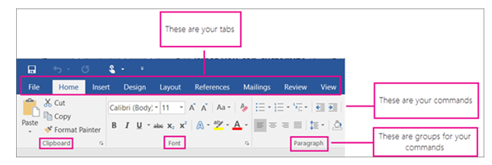
Tab | x | x
Group | x | x
Styles | Home | Styles | 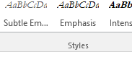
Pictures | Insert | Ills. | 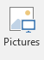
Margins | Layout | Page Setup | 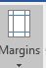
Close
Mailing
Table of Contents
New
Full Screen Reading
Gridlines
Tables
Spelling and Grammar
Cut
Copy
Paste
Underline

Word on the Ribbon | What Tab is it located Under? | What Group is it in? | How does it look? Insert the icon.  It must be the same picture from the ribbon nothing else will be accepted.
Normal
Web Layout
Header and Footer
Labels
Spelling and Grammar
Insert Citation
Navigation Pane
Page Number
Center
Chart
Italic
Print
Open
Find
Bullets
Numbering

Word on the Ribbon | What Tab is it located Under? | What Group is it in? | How does it look? Insert the icon.  It must be the same picture from the ribbon nothing else will be accepted.
Sort
Increase Indent
Replace
Center
Decrease Indent
Save As
Zoom
Orientation
Ruler
Word Count
Align Left
Page Break
Thesaurus
Line & Paragraph Spacing
Replace
Envelopes

